- Download/Install OpenEMR: OpenEMR (http://www.open-emr.org/ ) will be utilized as part of the project this semester. Download can be found at:
http://www.open-emr.org/wiki/index.php/OpenEMR_Downloads
Note that I have successfully downloaded and installed:

Windows: Pre-installed OpenEMR with the XAMPP Package
- xampp-openemr-4.1.2.zip (MD5 sum: 5b6dec1a56241e6fffafe84cc4e045e7) - See more at: http://www.open-emr.org/wiki/index.php/OpenEMR_Downloads#sthash.5lUGCCxW.dpuf
- Installation Instructions

I used Option 2 as below:

Option 1: Installation as service
- Download package here: xampp-openemr-4.1.1.zip (MD5 sum: 455bf1eeed1cf73de3933dd8a608a9f3)
- Right click downloaded file and select 'Extract All...'
- Choose to extract to 'C:' (extracting to C: is required)
- Right-click on C:/xampp/xampp-control and select 'Run as administrator'
- Click the red X to left of Apache
- Click the red X to left of MySQL
- Then click 'start' for Apache and MySQL
- Login at http://localhost/openemr with user:admin pass:pass
- See more at: http://www.open-emr.org/wiki/index.php/OpenEMR_4.1.1_XAMPP_Package_Installation#sthash.GnMpZSDh.dpuf

After your install of OpenEMR has been completed, the Double Click will on C:\xampp\xampp-control will open the window below where I have already clicked on the Start buttons for Apache and MySQL (see green highlight).
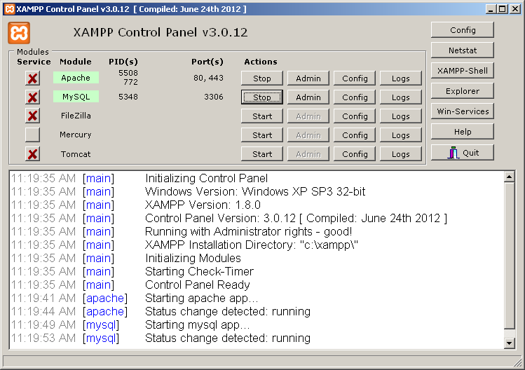

In the final step, go to http://localhost/openemr and logon with user admin and password pass. Now you can create yourself as a new patient under Patients - New/Search which brings up the Add Patient screens. Click on the Contact Box to add contact info, and then Create New Patient.
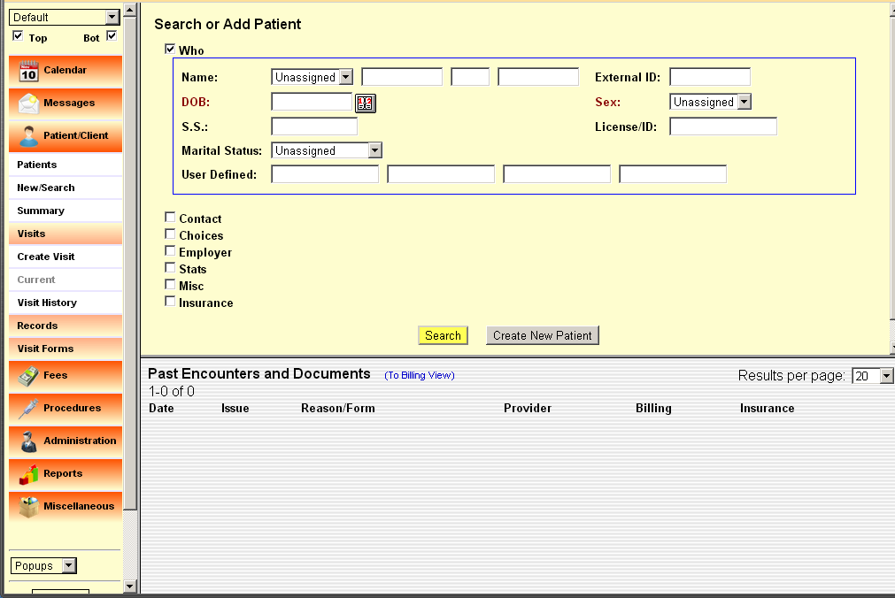
Once you have used the button Create New Patient, the screen below appears. You can provide additional information when the creation completes and the patient screen comes up.




