Download/Install Android SDK: http://developer.android.com/sdk/index.html (choose Windows, Mac OSX, Linux, 32 or 64 bit). or see http://www.ibm.com/developerworks/opensource/tutorials/os-eclipse-androidwidget/index.html?ca=dgr-eclipse-1 for an approach that installs Eclipse with Android in multiple steps. We recommend that do a new installation even if you currently have Eclipse installed. This will allow all of the correct versions of the various applications and plug ins to be installed. Remember, the Eclipse installation is not like typical programs on a Windows platform; the install is simply an unzip to a directory, so you are allowed to install multiple versions of Eclipse on the same CPU as long as they use different directories. If you are doing an installation that augments one for Eclipse, please make sure that you define a different workspace.
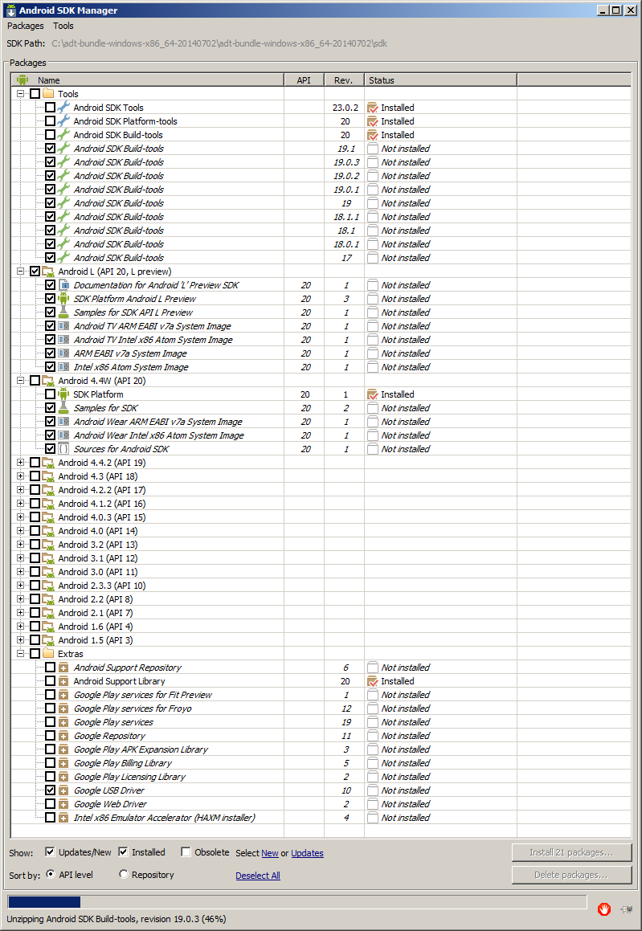
Your existing version of Eclipse will have a workspace defined such as: C:\Documents and Settings\Steve\workspace. Make sure that you define a new directory for the Android SDK install; the two Eclipse installs cannot share the same workspace. If you use the default in Extract the downloaded file into the C:\ directory. The extraction is essentially the install. Once extracted, you will have a directory C:\adt-bundle-windows-x86_64-20140702 defined. In the directory, run the SDK Manager.exe application which displays the screen below. Select the three boxes: Install Android SDK Build Tools 17, Install Documentation for Android SDK, Install Samples for SDK, and Install Android 2.3.3 to complete the installation process of the Android SDK. Note that SDK Manager.exe is in the directory: C:\ adt-bundle-windows-x86_64-20140702 while ecpilse.exe is in C:\ adt-bundle-windows-x86_64-20140702 \eclipse. We suggest you make shortcuts to each of them on your desktop. Make sure that you create a device for Android that has less than 750Meg or the simulator may have difficulty running. Below is the AVD Manager.
