SECTION A: Sprint Backlog

The sample sprint backlog for the Personal Health Assistant project is shown in Figure A.1. This is a variant of the sprint backlog on slide 25 of http://www.engr.uconn.edu/~steve/Cse2102/finagile.pptx and captures. There are four product backlog items (PBIs –see Figure F.1 in Section F). For each item, there is:
- Primary and secondary individual in charge of the item (initials)
- The different task for the PBI in the sprint.
- Effort in hours for weeks 1, 2, 3, and 4
Note that each team member is 10 hours/week or 40 hours for the sprint.

The excel spreadsheet is an embedded object in MS word. You can right click, Worksheet Object, Open and it will open the spreadsheet in excel. You can use this as a template for your sprint backlog.

Figure A.1 Sprint Backlog for the Personal Health Assistant Project.

SECTION B: User Stories/Use Cases

The initial use case diagram of PHA is shown in Figure B.1 and illustrates the main possible actions of both the patient and the health care provider. The patient has a profile designated by his or her personal Microsoft HealthVault account. By signing in through this account, the patient will have the options, through the PHA to record daily activity, use the disease center to monitor specific health concerns, and use the medication center to track and record medication and nutritional supplements. On the other end, the health care provider will have his or her own profile and will be able to view the patient information, analyze information recorded by the patient, provide feedback and request additional information.
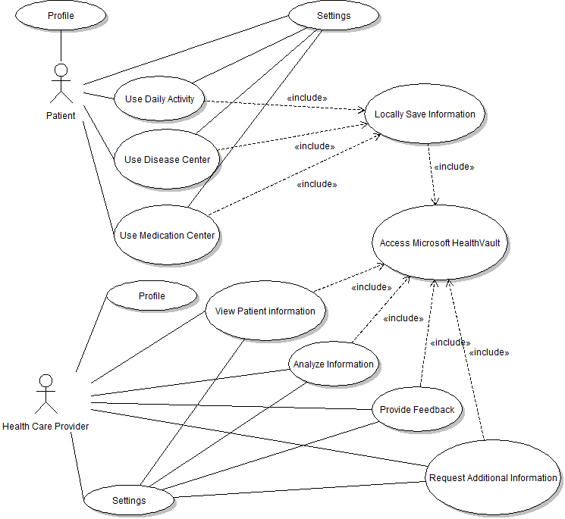
Figure B.1: Use Case Diagram for PHA Patient and Provider Users.
There will be another component (server side) of the proposed system to handle disease specific analysis. Advanced analysis, such as graphs and algorithms (e.g. diabetes algorithm), will occur when the health care provider accesses the information. In this way, the interaction between HealthVault and the patient user end remain very basic, simply receiving a request and either storing or relaying a JSON object. The patient use case diagram in Figure B.2 details the patient and interface interactions.

Figure B.2: Use Case Diagram of Patient Options
The provider app allows the healthcare provider as shown in the use cased diagram in Figure B.3 to review medication information and daily measurement input from their patients. It would also alert the healthcare provider of any potential threats to the health of the patient based on the data provided by the patient. This interface will allow the health care provider to take the following actions: view the patient information, analyze information recorded by the patient, provide feedback and request additional information.

Figure B.3 Use Case Diagram of Health Care Provider Options
From a healthcare provider’s perspective, he/she has the option to specify requested information in addition to the default options on the user interface end. Mainly, the healthcare provider interface provides means to view and analyze the data and give patient feedback. This is not done through direct communication with the patient, but again through HealthVault using JSON objects. The health care provider end holds the functionality for advanced analysis
SECTION C: User Based Specification/Interfaces
The current conceptualization of the PHA with its current and to be include features include a series of screens as shown in Figure C.1 that will have options corresponding to each of the possible patient actions: Profile, Medication Center, Disease Center, Daily Activity, and Settings. We examine each of these options in turn.
The first screen (upper left in Figure C.1), allows the user to enter their personal information, such as name, age, gender, profile picture, and Windows Live ID account. Since Microsoft HealthVault allows the user to sign up using a Facebook account, we have included an option that allows the user to link their Facebook account and HealthVault database. Users who don’t have either account can create a Windows Live ID in this section or in a separate browser. The bottom half of the screen also shows the medicines that user is currently taking.
The Mediation Center (shown in the upper middle of Figure C.1) keeps track of the medicines the user is currently taking and gives information on medication. The medications are categorized in the disease the medicines are related to. When a user selects a medicine from the drop-down menu, related information to this medicine is displayed, such as the last time the user has taken the medicine, recommended daily intake, and instructions on medication.
The Disease Center (shown in the lower left of Figure C.1) is the place for a patient to manage and keep track of their condition, gives patient data which is related to the disease the patient wishes to track, and generates diagrams and graphs to allow the patient to see a progression in their health.

The Daily Activity Screen (shown in the lower middle of Figure 5) lets the patient enter in daily information. This includes their diet, medication intake, exercise, and other data related to the specific diseases (daily measurements). The data entered is then uploaded to Microsoft HealthVault using an openEHR. Finally the settings option let users modify their personal info, alerts setting, reminder, sync calendar, backup data, and privacy settings.

.

Section F: Product Backlog Items (PBI)
The product backlog items (PBI) for the Personal Health Assistant project in Figure F.1. The leftmost column of Figure F.1 contains the six PBI entries identified so far, where the size/complexity of each item is labeled with: where S=Small, M=Medium, L=Large, and XL= extra L. Of those six, four have been chosen for the initial sprint (second column of Figure F.1), and for those four, all of the sprint items have been identified (blue boxes). Note that this figure is using the notation from: http://scrumreferencecard.com/ScrumReferenceCard.pdf
The PPT below is an embedded object in MS word. You can right click, Presentation Object, Open and it will open the spreadsheet in PPT. You can use this as a template for your PBI/Sprint backlog.
Figure F.1 PBI and Sprint Backlog for Personal Health Assistant.

