SECTION A: Sprint Backlog

The sample sprint backlog for the ROOMs project is shown in Figure A.1. This is a variant of the sprint backlog on slide 25 of http://www.engr.uconn.edu/~steve/Cse2102/finagile.pptx and captures. There are four product backlog items (PBIs –see Figure F.1 in Section F). For each item, there is:
- Primary and secondary individual in charge of the item (initials)
- The different task for the PBI in the sprint.
- Effort in hours for weeks 1, 2, 3, and 4
Note that each team member is 10 hours/week or 40 hours for the sprint.

The excel spreadsheet is an embedded object in MS word. You can right click, Worksheet Object, Open and it will open the spreadsheet in excel. You can use this as a template for your sprint backlog.

Figure A.1 Sprint Backlog for the Rooms Project.
SECTION B: User Stories/Use Cases

Users are grouped into three main categories: guests, players, and administrators. These roles and their capabilities are described in the use-case diagrams in Figure B.1.
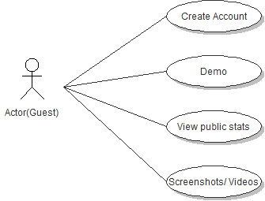
Figure B.1 - Guest use-case diagram for website - Nikolaj

Guests are able to access limited features on the website, such as public rankings, viewing public user generated content, or registering to become a “Player” as shown in Figure B.2. These users have the most restrictive permissions, but will be allowed to play a demo version of the game anonymously.
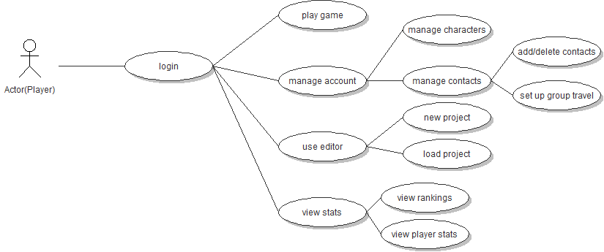
Figure B.2 – Player use-case diagram for website – Nikolaj.

Players represent the majority of users and will be able to log into the game and access their own personal information, as well as content that they’ve generated. Players “play” the game as intended by design and can also log into the website with the same credentials to access the editor. Players may also view the player statistics of other players, including content created with the editor, and any statistics associated with it, and inherit all of the permissions of Guest users. Additionally players can manage their account through the website by managing their in-game characters and contacts.

Administrators are privileged users. These users have full access to modify almost everything. For example, they can view any information available to players, ban given players from the site temporarily and/or permanently, or view currently banned players and unban them. Additionally admins have control over custom content uploaded by users.

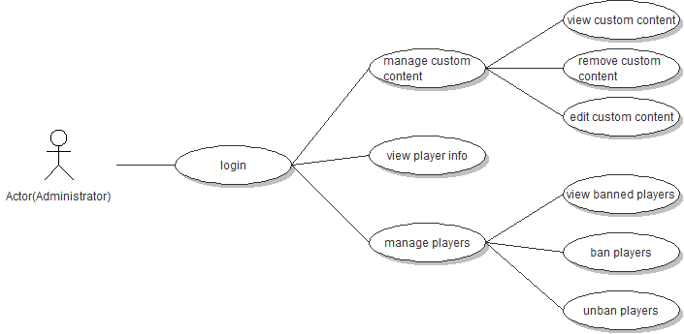
Figure B.3 - Admin use-case diagram for website – Nikolaj

As previously discussed, ROOMS will feature three editors accessible from the website: a room editor, an item editor, and a monster editor. The editors will let you create new content which you can upload to the game and can be encountered by all players. Everything made with the editor will have a chance to be encountered in a player’s game. Figure B.4 (below) shows the general use case diagram for the various editors:
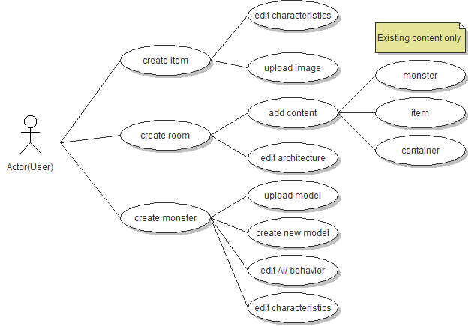

Figure B.4 - User use-case diagram for editor. Nikolaj

As you can see from Figure B.4, the user will be able to edit not only how their content looks, but also all of its characteristics and effects on the game. All content created through the editors will have a ‘rarity’ level calculated. This ‘rarity’ is determined based on how ‘good’ or difficult the object is. For example:
- if an item is extremely powerful, its rarity will increase.
- if a monster is made very strong, its rarity will increase.
- if a room has many rare or powerful items, its rarity will increase.
In addition to the calculated rarity, as the content appears in game, it will accumulate aditional statistics. For example, a monster may accumulate a set of ‘success rates’ that will correspond to a level of difficulty to defeating that monster. These stats will also contribute to the frequency the item appears in the game.
Website users will fall into the following three user roles: Guest, Player, and Administrator. A brief description of each role along with a use-case diagram is provided below:

- Players in Figure B.5 represents the majority of users and will be able to log into the game and access their own personal information, as well as content that they’ve generated. Players “play” the game as intended by design and can also log into the website with the same credentials to access the editor. Players may also view the player statistics of other players, including content created with the editor, and any statistics associated with it, and inherit all of the permissions of Guest users.

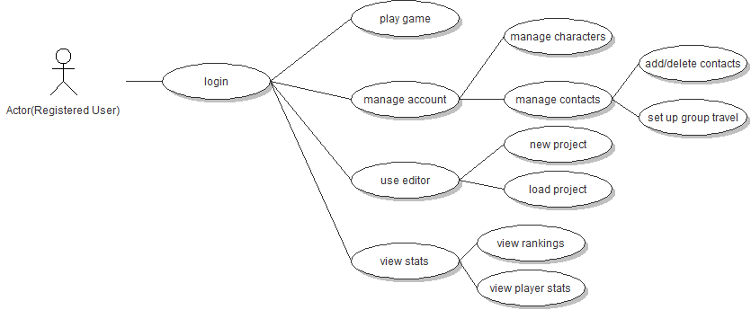
Figure B.5 - Registered User use-case diagram for website - Nikolaj.

- Guests in Figure B.6 are able to access limited features on the website, such as public rankings, viewing public user generated content, or registering to become a “Player”. These users have the most restrictive permissions, but will be allowed to play a demo version of the game anonymously. No personal data should be tracked for these users.

Figure B.6 - Guest use-case diagram for website - Nikolaj

- Administrators in Figure B.7 are privileged users. These users have full access to modify almost everything. For example, they can view any information available to players, ban given players from the site temporarily and/or permanently, or view currently banned players and unban them. Additionally admins have control over custom content uploaded by users. Administrator accounts should be monitored for unauthorized access. Security measures such as 2-step authentication might be considered since unauthorized access to these accounts will cause many headaches.

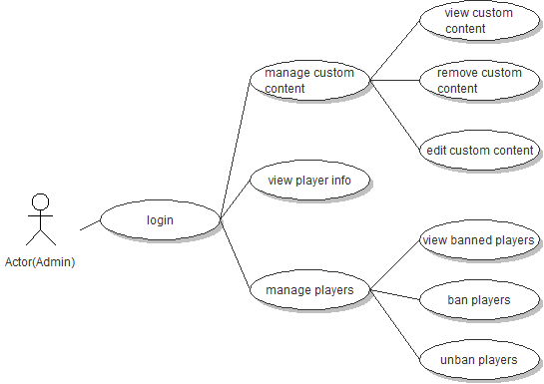
Figure B.7 - Admin use-case diagram for website – Nikolaj

SECTION C: User Based Specification/Interfaces
A mockup screen of the in-game interface is shown in Figure C.1. When played in the browser, the majority of the game is controlled with the mouse. Depending on what element in the game environment the players click on, the avatar will perform a corresponding action, such as moving to a location, picking up an item or attacking a monster. Several hot keys on the keyboard can also be assigned for quick access to the inventory. Other than that the keyboard will only be used for the room chat.
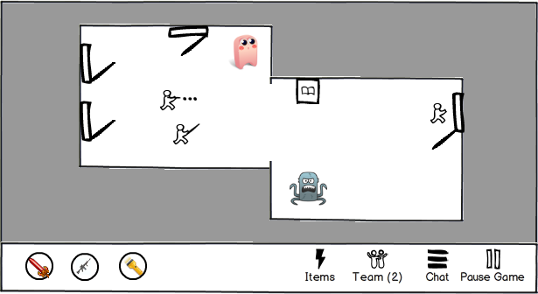
Figure C.1. Screen Mockup of the Rooms Game - by Ashley

All system interactions are server/client based. While most of the game logic (path-finding, monster AI, animation, etc.) occurs in the client (desktop or mobile device), the server keeps track of the current game state (currently active rooms, players stats, etc.). This leads to frequent communication between the client and the server. One of the more unique technical aspects of Rooms is that the game is an MMO playable both in the browser and on mobile devices. For that reason two main performance bottlenecks have to be taken into consideration: the server/client interaction and the limited processing power of smart phones. These are handled by limiting the amount of information sent back and forth between the client and the server to a minimum and by avoiding 3D graphics which might be too taxing to smart phone processors.

C.1 Website Home Page
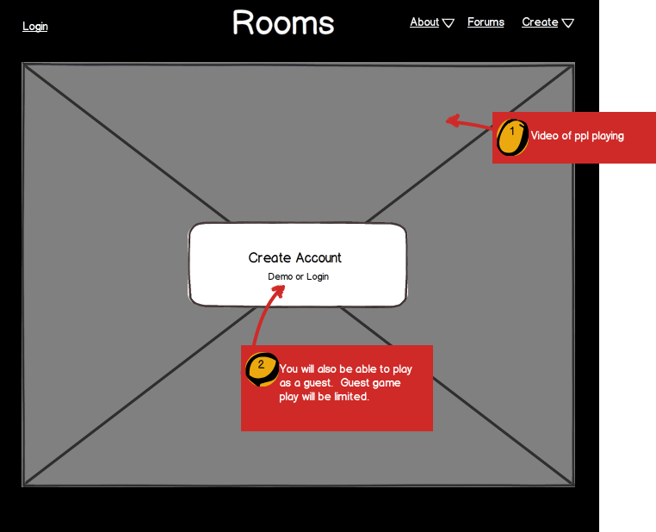
As discussed previously, ROOMS will have both a mobile app and a website. The Website will afford much additional functionality including editors to upload custom content to the game. The basic layout of the site will look like Figure C.2 below. The one on the left is what it will look like when you are logged in and the one on the right is what it will look like if you are not logged in.
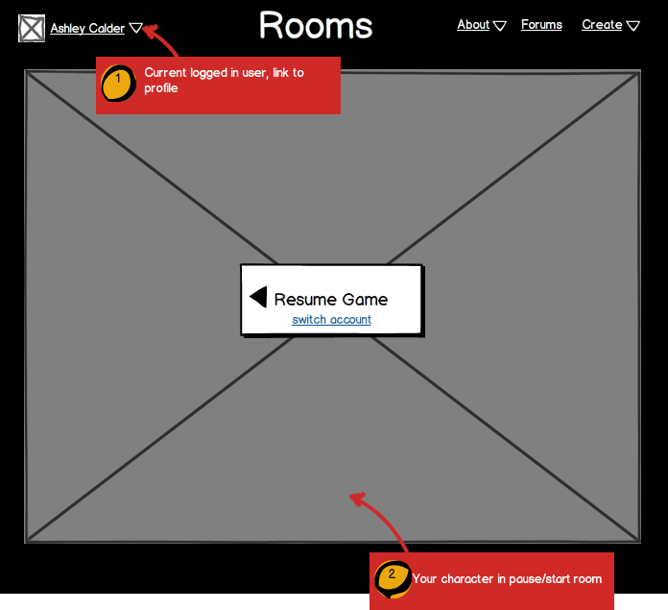

Figure C.2 - Website Mockups of Home Page - Ashley
C.1.1 Logged In
As you can see from the mockups, when a user is logged in you can see their name in the top left corner. We will display the user’s First & Last name (which does not need to be unique). We will also show their profile picture. By clicking on their name, you will access the following menu:
User
- Profile: a link to the member’s profile
- Settings: a place where they can edit settings on their account
- Logout: a link to logout and end their session
As shown in the mockups, there are three additional menu items on the top right of the screen. From these you will also be able to access the following pages:
About
- What is rooms?: a description about ROOMS
- How to Play: a basic tutorial about how to play the ROOMS game
- Development Team: information about the team that built ROOMS
Forums
Create
- About creating custom content: a tutorial to create custom content
- Create New Rooms: the editor to create custom rooms
- Create New Items: the editor to create custom items
- Create New Monsters: the editor to create custom monsters
When a user is logged in, the home screen will be dominated by the current state of the user’s game. By clicking the ‘Resume Game’ button, they will be able to pick up game play where they last left off.

C.1.2 Logged Out
In the case when no user is logged in, rather than showing the previous game state, a video will be displayed with clips of other players playing. This will give new site visitors an incentive to create an account & play. Additionally, guests will have the ability to demo the game. This will let them play a modified version of the game and determine if they wish to make an account.
Finally, by clicking the login button, users will be able to log in to their accounts and resume game play.

C.2 Website Profile
By clicking on a player’s name within the website, you will be taken to that player’s profile shown in Figure C.3. On a player’s profile, you will be able to see their game stats, any players they are teamed up with, and any custom content they have created in the editors.
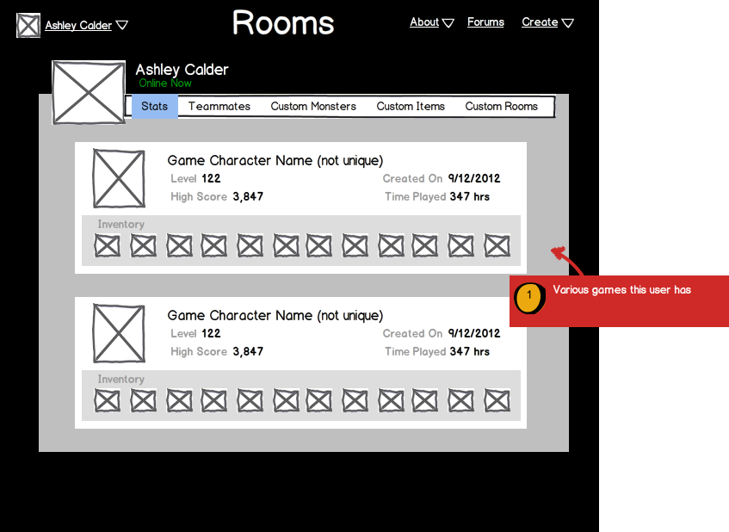
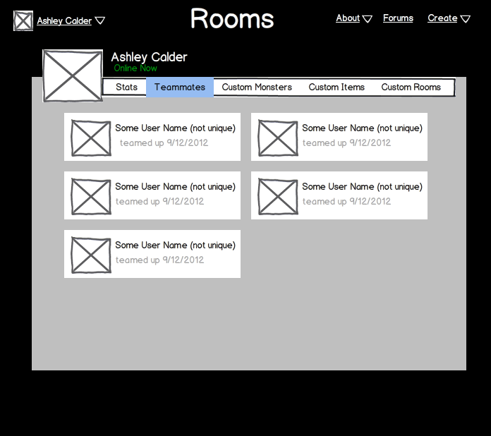

Figure C.3 - Website Mockups of Profile - Ashley

The mockup on the left in Figure C.3 is a depiction of the ‘Stats’ tab on a profile page. . We will allow players to save multiple games in Rooms. Each game will have its own game character & various stats associated with that game. The mockup on the right of Figure C.3 is a depiction of the ‘Teammates’ tab. By clicking on the teammates tab, you will be able to see that various users that you are teamed up with.
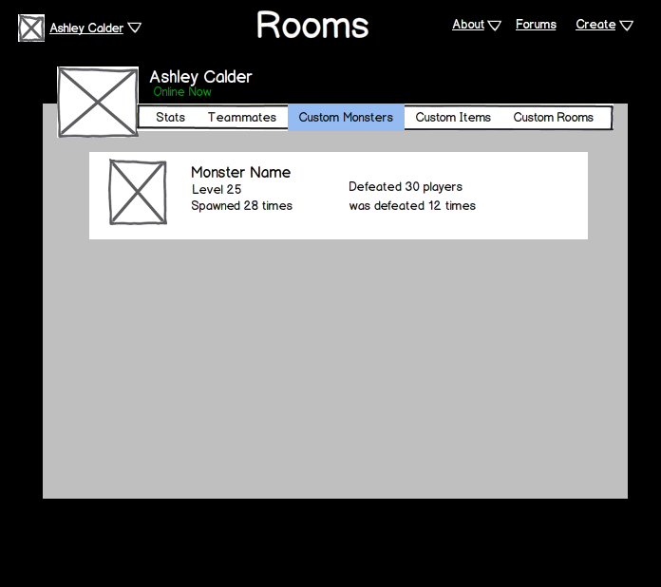
Figure C.4 - Website Mockups of a User’s Custom Content displayed on their Profile - Ashley
In addition to the ‘Stats’ and ‘Teammates’ tabs, you will also be able to see the custom content a user has created. Each will include a variety of stats about the object (as shown in Figure C.4 above).

C.3 Gameplay
Figure C.5 is a mockup of what the general game will look like on both the website and the app. As you can see, the top is dominated by the current room you are in while the bottom portion of the screen will have a simple menu bar.
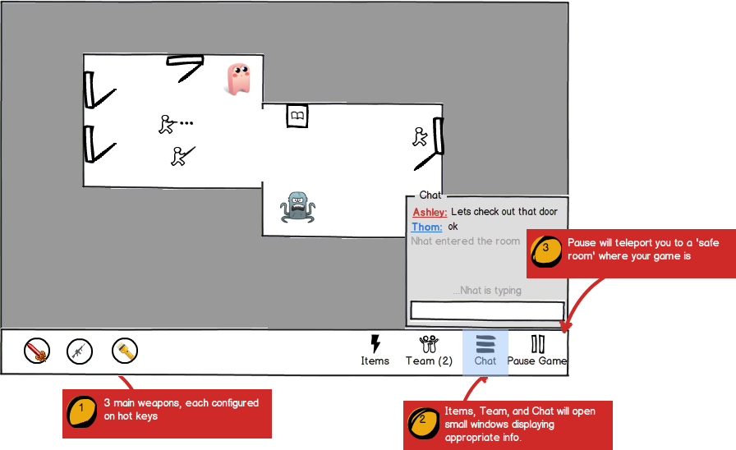
Figure C.5 - Gameplay - Ashley

As you can see from Figure C.5, comment 1, you will be able to configure three main weapons. These weapons will be quickly accessible from hotkeys or clicks on the website, and taps on the app. In reference to Figure C.5, comment 2, you will be able to chat with people in the same room. You will be able to see in the chat whenever other people are typing and whenever they enter/exit the room. By clicking on a player you will be able to team up with them. Additionally, by clicking the ‘Team’ button on the bottom menu, you will be able to see all the people in the room who you are currently teamed up with. In reference to Figure C.5, comment 3, you will be able to pause the game. By tapping or clicking the ‘Pause Game’ button, you will be able to teleport your character to a safe room where your game is paused. Doing this will fork the current room you are in (minus the players) & save it so you can resume play in it later. The safe room will always take you back into the room you were in before (not a new one).
Items will also be easily accessible from this bottom bar as shown in Figure C.6. By clicking (or tapping) on the item, you will be able to access a set of actions to do with them. Depending on the item, these will include:
- using the item
- giving the item to a player in the room
- combining the item with another item (to create a new item)
- accessing the info for the item.
- discarding the item
The info window for the item will show the known effects of the item and any notes you have made about that type of item. Because the effect will not be initially known, the notes section is important because it will allow players to discuss and make note of an item’s speculated effect.
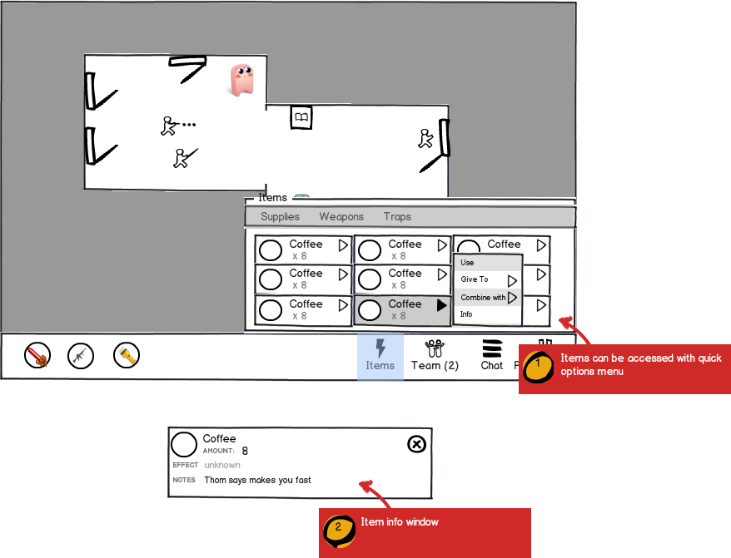
Figure C.6. - Game play, items - Ashley
C.4 Editor
As previously discussed, ROOMS will feature three editors accessible from the website: a room editor, an item editor, and a monster editor. The editors will let you create new content which you can upload to the game and can be encountered by all players. Everything made with the editor will have a chance to be encountered in a player’s game.

C.4.1 Item Editor
When you create an item with the editor, you will be able to totally configure its look, properties, and characteristics. The rarity of these items will be determined based on these characteristics. Figure C.7 below is a mockup of what the item editor will look like.
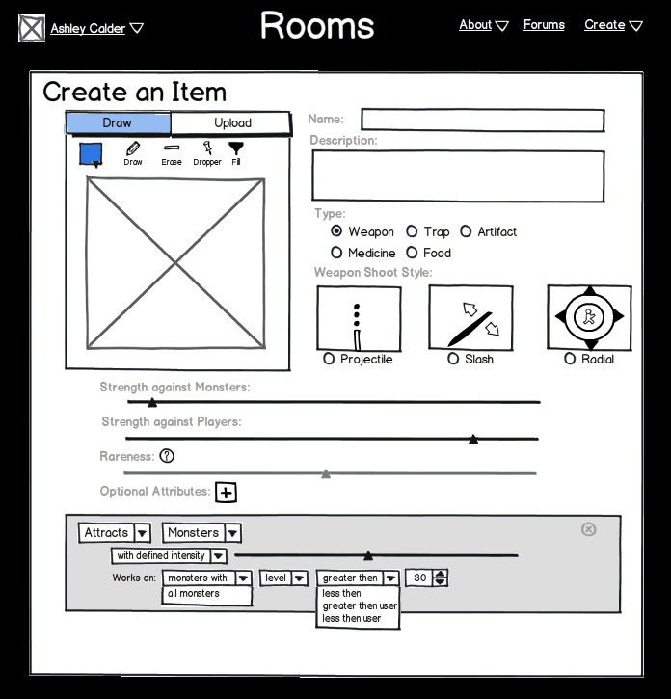
Figure C.7 - Item Editor - Ashley

Figure C.7 is an example of designing a weapon. The fields will be different based on the type of item you are creating. For a weapon, you will be able to decide its attack style, strength, and any additional attributes that the item will cause in game.

C.4.2 Monster Editor
The Monster editor will let you design a monster that will appear in the game. Because we plan to feature ‘intelligent’ monsters, the user will be able to highly configure the monster’s behavior based on a stimulus and response. Figure C.8 is a mockup of the Monster Editor.
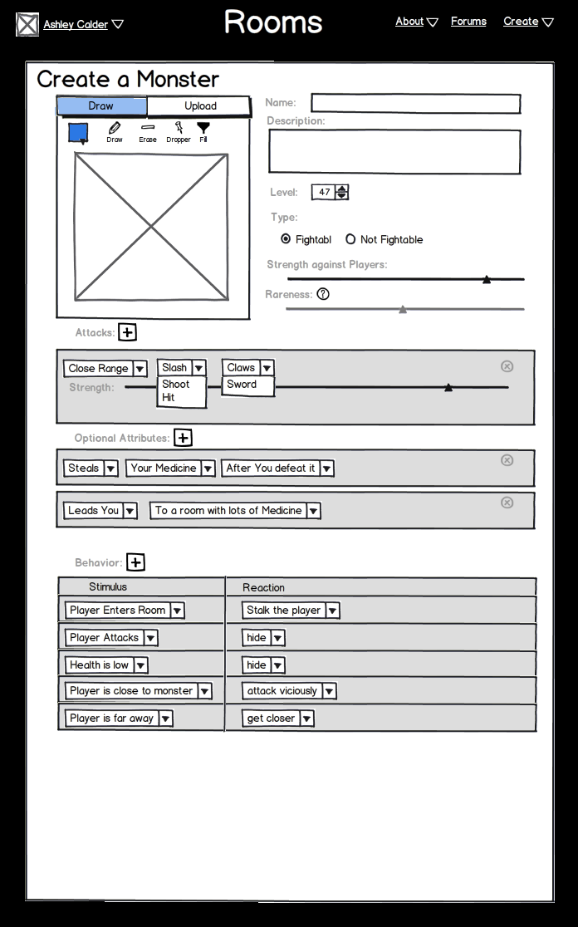
Figure C.8 - Monster Editor - Ashley

As with the item editor, the rareness of each monster is configured automatically based on the selections the user makes for the monster’s level, behavior, and attributes. This is designed to ensure that there is a fair distribution between easy and difficult monsters as you play. Additional stats about each monster will be collected as they are encountered. These will be used to describe the success rate or difficulty of each monster.

C.4.3 Room Editor
The room editor will let users create rooms. These rooms will be encounterable during game play. When a player enters thru a door, they will either be taken to a new random room, a room with another player in it, or a room that has been created & uploaded by a player through the room editor.
Figure C.9 is a mockup of the Room Editor.
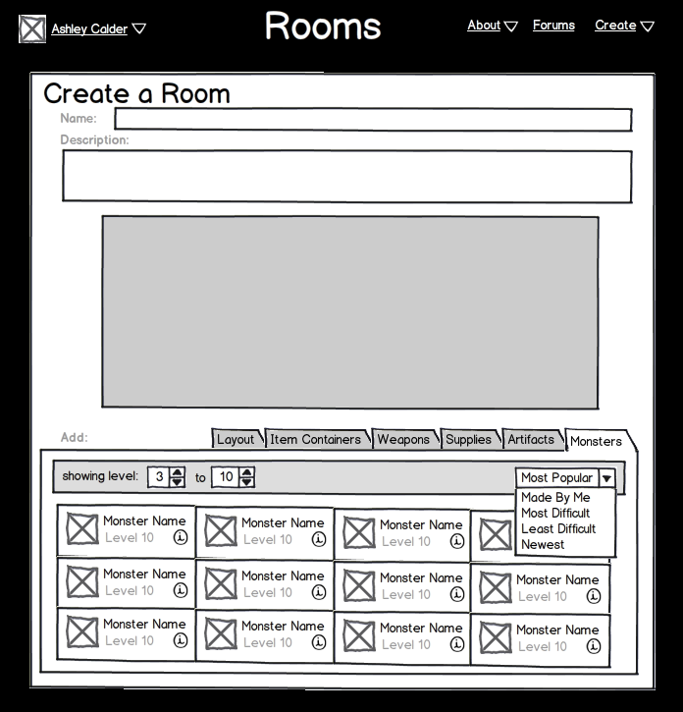
Figure C.9 - Room Editor - Ashley

Each room will have many options to add. You will essentially be configuring the initial setup of the room. The editor will use a drag & drop interface to add item containers (which will hold a set of items), supplies, weapons, artifacts, and monsters. The layout tab will allow you to change the look & feel of the room. You will be able to add walls, move the doors, change the tiling images, and other things related to the room’s appearance.

Section F: Product Backlog Items (PBI)

The product backlog items (PBI) for the ROOMS project in Figure F.1. The leftmost column of Figure F.1 contains the six PBI entries identified so far, where the size/complexity of each item is labeled with: where S=Small, M=Medium, L=Large, and XL= extra L. Of those six, four have been chosen for the initial sprint (second column of Figure F.1), and for those four, all of the sprint items have been identified (blue boxes). Note that this figure is using the notation from: http://scrumreferencecard.com/ScrumReferenceCard.pdf
The PPT below is an embedded object in MS word. You can right click, Presentation Object, Open and it will open the spreadsheet in PPT. You can use this as a template for your PBI/Sprint backlog.
Figure F.1 PBI and Sprint Backlog for Rooms.

