Initial User Manual

About the game:
Drone wars is an augmented reality first person shooter which uses a Parrot (Augmented Reality) AR Drone 2.0 Multi-Rotor (http://ardrone2.parrot.com) controlled by an Android Device to essentially dogfight other drones. It is going to be a free-to-download application which will be available on Google Play Store.

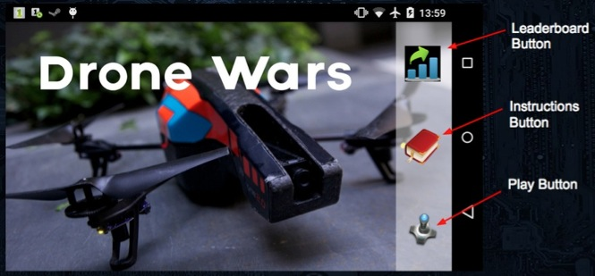
Figure 6 Home Screen

Home screen:
When the app first opens, the user is brought to the home screen. Figure 6 shows the Home Screen and the three buttons available to the user. From the home screen the user will be able to choose from 3 options: the first is Leaderboard, the second is Instructions, and the last is Play Drone Wars. By clicking one of the buttons, the player will be directed to the corresponding screen.

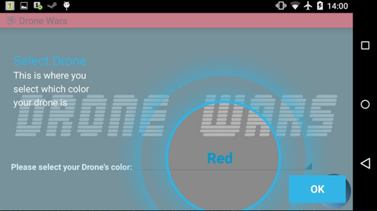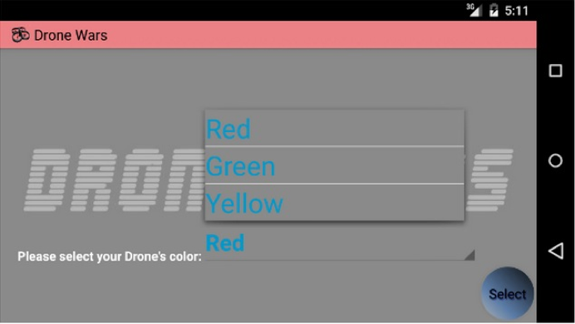
Figure 7 Play Screen: Drone Selection
Play Screen:
If it’s the first time that the user selects the Play Drone Wars button, a partial dimmed Play Screen Instruction will pop up on top of the Drone Selection screen. The Play Screen Instructions label and explain the various parts of the Play Screen (See Figure 7, left part). If it is not the user’s first time selecting Play Drone Wars, then the user will go immediately to the Drone Selection Screen (See Figure 7, right part).

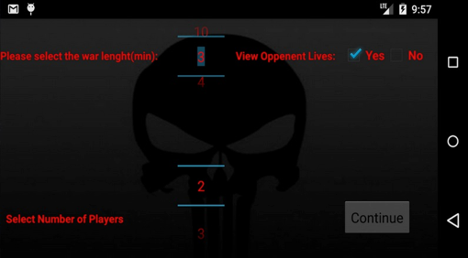
Figure 8 Play Screen: Game Mode setting

The player who selects the red drone will be allowed to set up the game mode. We allow the user to modify the length of game time in minutes (game time shall not be longer than than 10 minutes, which is beyond the drone battery life), the number of the players in the game, and whether to view the opponent's life points. After determining all the arguments by hitting Continue, the user will be directed to Play Interface. If it’s first time of the player entering the Play Interface, the player will see a similar instruction as the one pop up in Drone Selection.

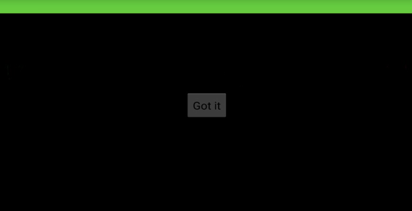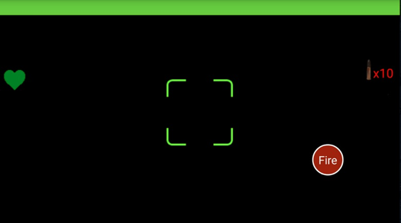
Figure 9 Play Screen: Playing Interface

After setting the game mode and every player having picked their drones, all the players will see the Play Interface. Figure 9 shows the current Play Interface and Figure 10 shows the final Playing Interface Mockup. The Mockup better demonstrates the layout of Playing Interface. As a multi-player game, different physical drones will have different colors on their surface. The background of the action bar on the device screen as well as other UI components will be the color of the drone that you picked before playing. In the center of the action bar is the game timer. It shows the time remaining of the current game. On the left of the status bar, there is a Wi-Fi signal strength icon. This shows the Wi-Fi signal of the drone from the router of the server. Keeping this signal strength will allow us to detect if a player’s drone is too far away from the play area, so that the application can notify the player to go back. To the right, is the remaining battery of the drone. This allows the player and the application to keep track of the battery on the drone. If the drone’s battery reaches 5%, it will notify the player and go to emergency landing mode automatically. On the right side of the status bar, there is a the battery life of the phone.
The background of the game interface will be the video feed from the drone which is being controlled. In the upper left corner of game interface, there is the player’s remaining life points. In the upper right corner, there is the amount of ammunition remaining for the player. On the left side of the screen, it displays the color of drones that are still in the game. There are three controls on the bottom of the screen: the accelerometer activator, the joystick/fire button and the land button. The accelerometer activator allows the player to move the drone. As the accelerometer activator is pressed, the player need only to tilt the phone to control the drone movement. The joystick will control the drone’s direction as well as altitude. We will let the joystick be able to detect double tap, which will be the fire button. The red box on the screen is the indicator of the enemy drone, it will adhere to enemy drone whenever the enemy drone is in sight. In the middle of the screen, it is the target area. Whenever the player elects to shoot, the server will computes to see if a red box is in the target area. If so, the enemy is hit and its life points will be reduced by one. At the same time, the device of the player whose drone got hit will vibrate in response to the hit.

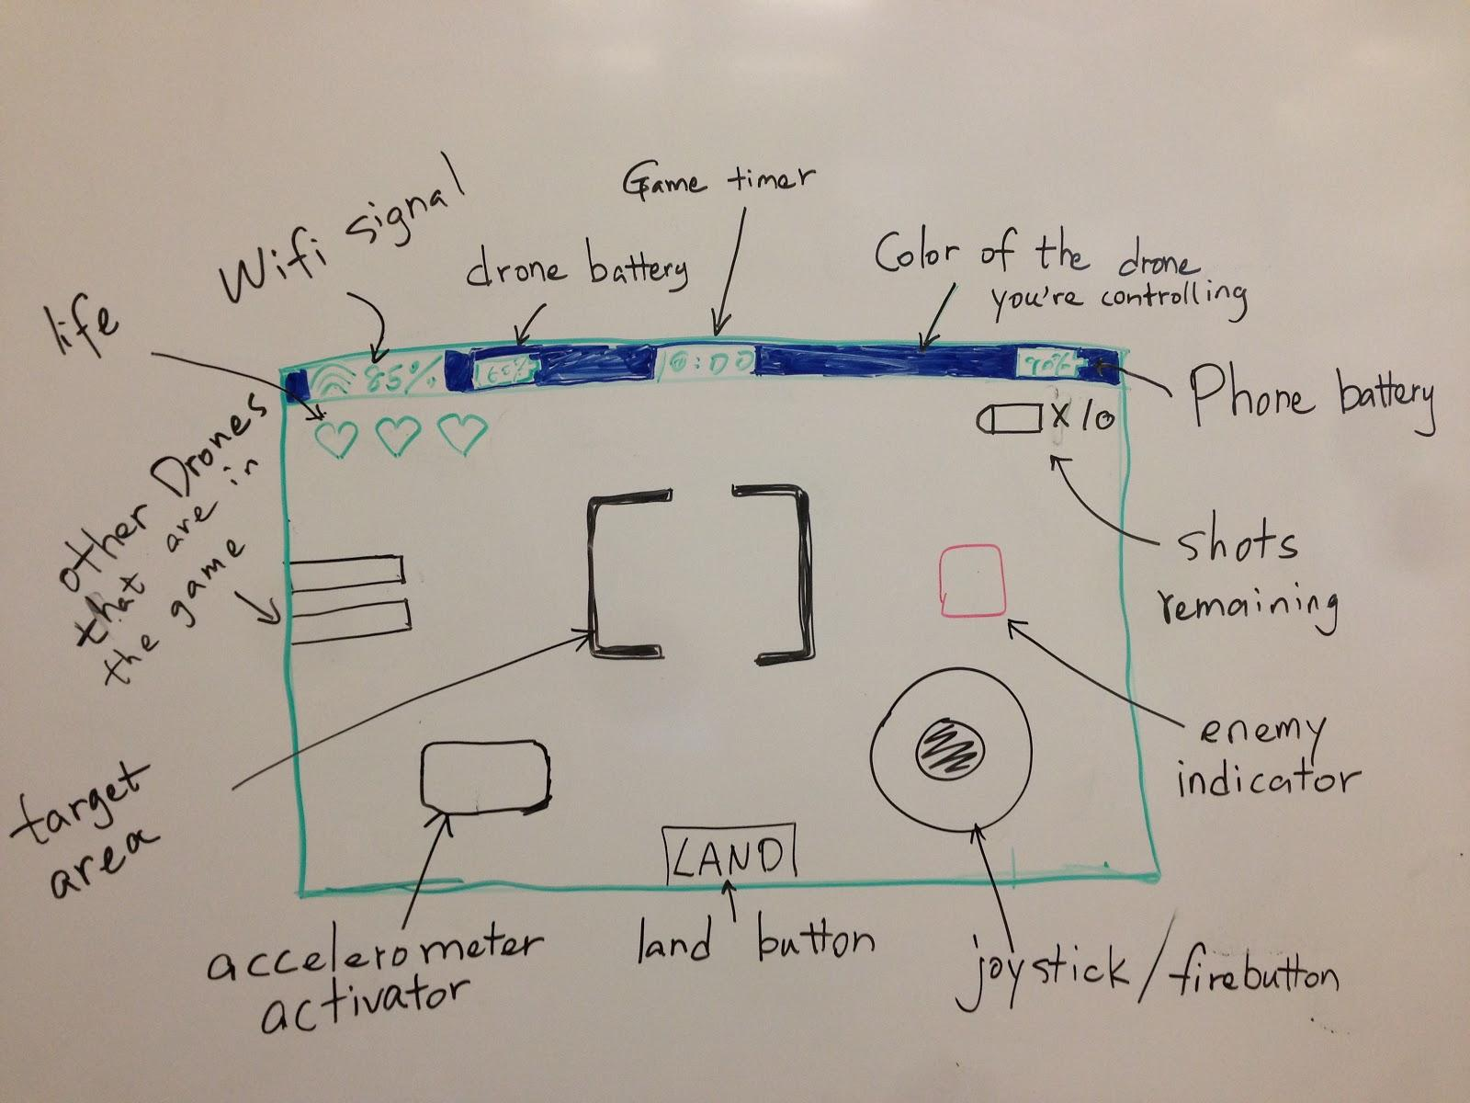
Figure 10 Play Screen: Playing Interface Mockup

Leaderboard Screen
When the user selects the Instructions button from the home screen, they are brought the Leaderboard Screen. They are brought to the Leaderboard Screen (this is an additional feature and will be implemented if time allows). The leaderboard will display the rank of the player in the system as well as other miscellaneous game statistics.

Instruction Screen

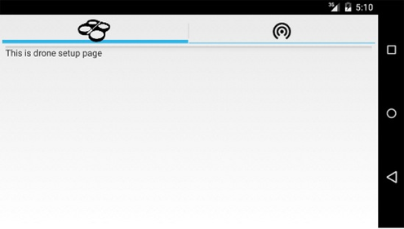
Figure 11 Instruction Screen

The Instructions Screen will enable the user to read and review the instructions for different parts of the app. The right part of Figure 11 shows the drone setup page instruction screen. In this screen, the user will be able to read instructions regarding drone setup. These instructions will help the user connect to their drone to the server so that they can then control their drone in game. The left part of Figure 11 shows the Wi-Fi setup page instruction screen. In this screen the user can learn how to connect their phone and drone to the server via Wi-Fi. These instructions will help make clear how to configure their Android device so that they can control their drone. It will also help the play troubleshoot if any of the device does not work properly.

