Team A
Initial Sprint
Section A: Sprint Backlog

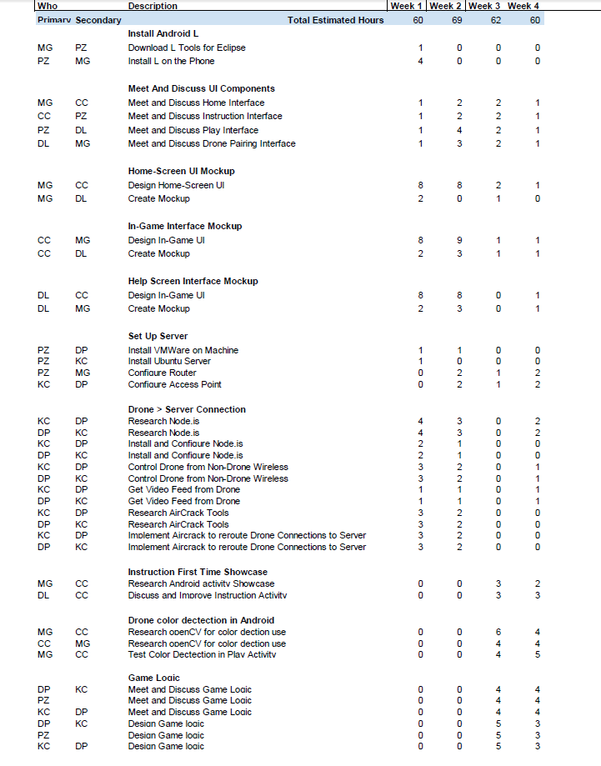

Section B:

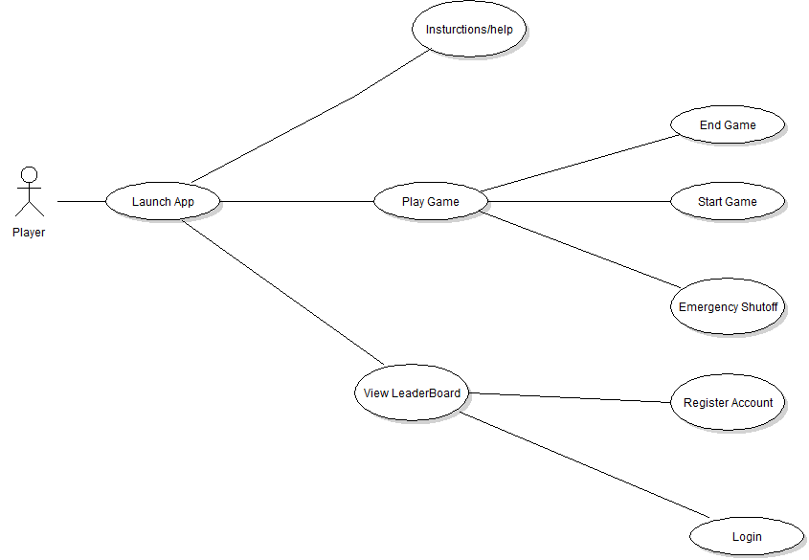
Fig B.1

The Drone Wars application has two different users, which are represented by the actors, they include the Drone and Player. In figure B.1 the player actor is shown with the use-cases Launch App, Instructions/Help, Leaderboard and Play Game. These user cases allows the user to control the drone actors and register their previously played game to the DWA leaderboard server by either creating an account or logging in. The player also has the ability to start and end their own involvement in the game.

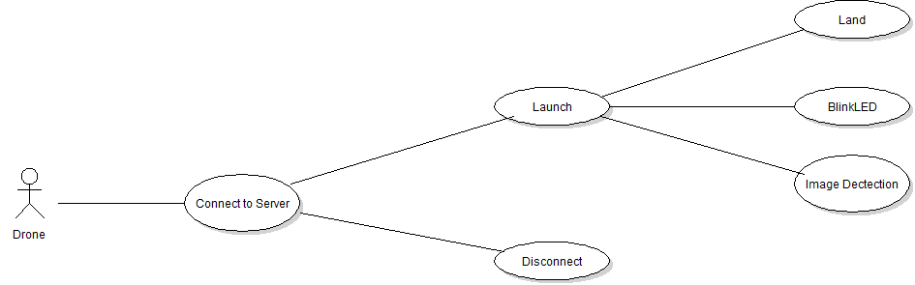
Fig B.2

From figure B.2, it is apparent that the drone actor has the ability to connect to the game server. The game server connects the Drone, to the game server and the player by IP. The Drone actor will be able to disconnect itself from the game server if its lives run out and it enters the auto land feature and it can disconnect if the player actor flies out of the designated games boundary. The drone actor also has the ability to blink its LED and image Detections.

Section C: User Based Specifications/Interfaces
C.1 Home-screen
When the app first opens the user is brought to the home screen. Figure C-1 shows the Home-screen and the three buttons available to the user.
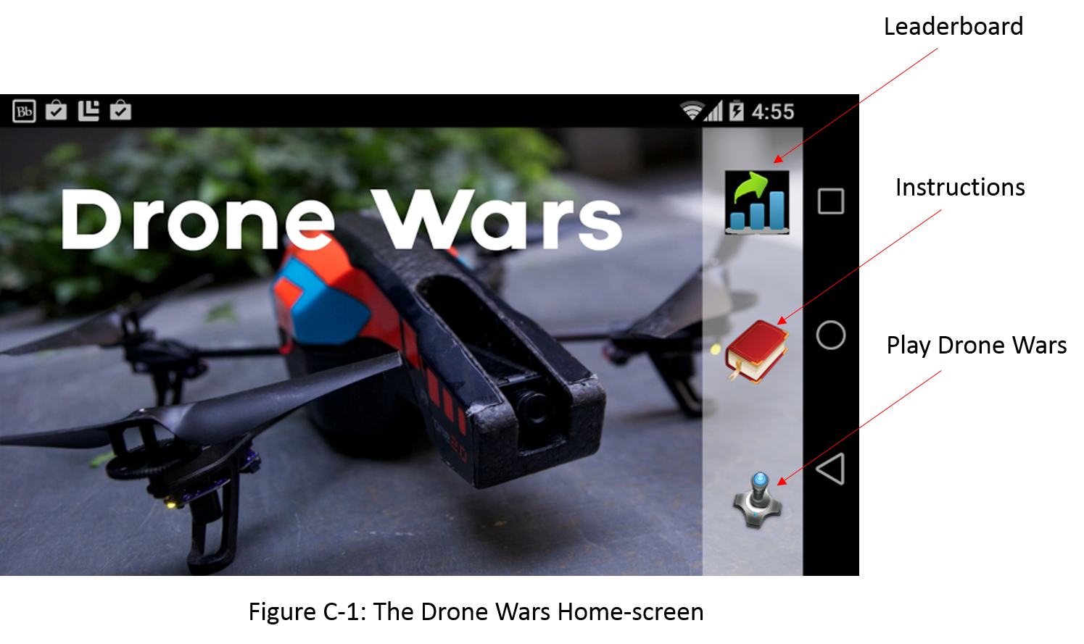
From the Home-screen the user will be able to choose from 3 options: the first is Leaderboard, the second is Instructions, and the last is Play Drone Wars. If the user selects the Play Drone Wars button for the first time then the user will be brought a help screen where the Play Screen Instructions will be shown. The Play Screen Instructions label and explain the various parts of the Play Screen. If it is not the user’s first time selecting Play Drone Wars then the user will go immediately to the Play Screen (See section C.2). When the user selects the Instructions button they are brought the Instructions Screen (See section C.3). If the user selects Leaderboard they are brought the Leaderboard Screen (this is an additional feature and will be implemented if time allows).
C.2 Play Mode
The mockup screen of the play mode is shown in Figure C-2. There are two main areas of the screen: the status bar and the game interface.
As a multi-player game, different drones will have different colors. The background of the status bar will be the color of the drone that you picked before playing. In the center of the status bar, is the game timer; it shows the time remaining of the current game. On the left of the bar, there is a wifi signal strength sign. This shows the wifi signal of the drone from the router of the server. Keeping this signal strength will allow us to detect if a player is too far away from the play area, so that the application can notify the play to go back. To the right, it is the battery of the drone. This allows the player and the application to keep track of the battery on the drone. If the drone’s battery reaches 5%, it will notify the player and go to emergency landing mode automatically. On the right side of the status bar, there is a the battery life of the phone.
The background of the game interface will be the video feed from the drone that is being controlled. In the upper left corner of game interface, there is remaining life of the drone. In the upper right corner, there is the remaining ammunition of the player. On the left side of the screen, it shows the drones that are still in the game. There are three controls on the bottom of the screen: the accelerometer activator, the joystick/fire button and the land button. The accelerometer activator allows the player to move the drone. As the accelerometer activator is pressed, tilting the phone to control the motion. The joystick will control the drone’s facing direction. We will let the joystick be able to detect double tap, which will be the fire button. The red box on the screen is the indicator of the enemy drone, it will show whenever an enemy drone is in sight; and the red box will follow the enemy drone. In the middle of the screen, it is the target area. Whenever the player make a shot, the server will computes to see if a red box is in the target area. If so, the enemy is hit.

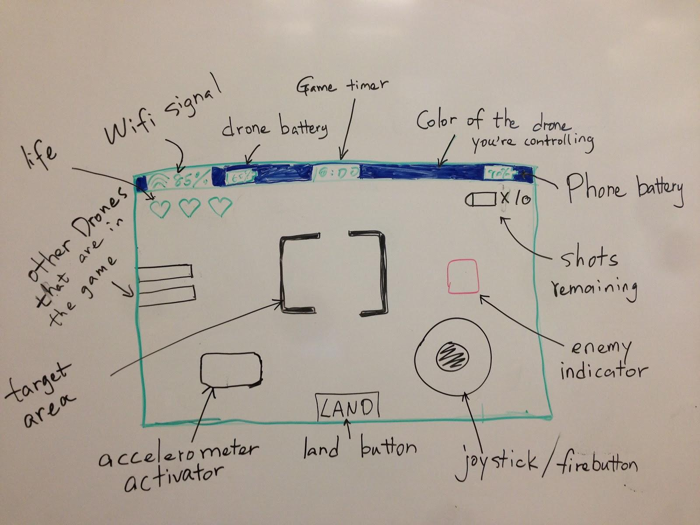
Figure C-2 The interface for play mode

C.3 Instructions Screen
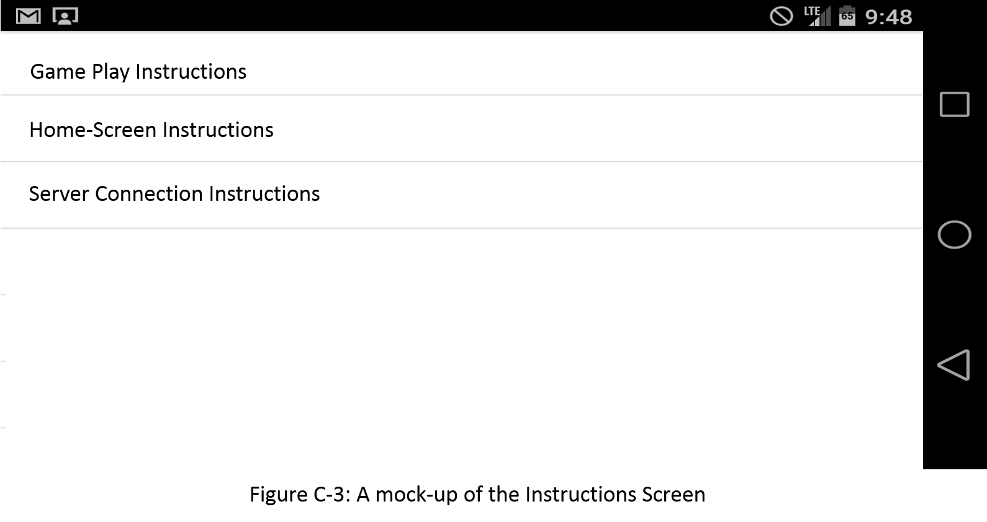
Figure C-3 is the mockup screen for the Instructions Screen. The screen will have multiple options for selecting the instructions you want to view. Selecting an instruction will bring you to another screen which displays the text and diagrams included in the instructions. Figure C-4 is a mockup of the screen which will display the selected instructions.

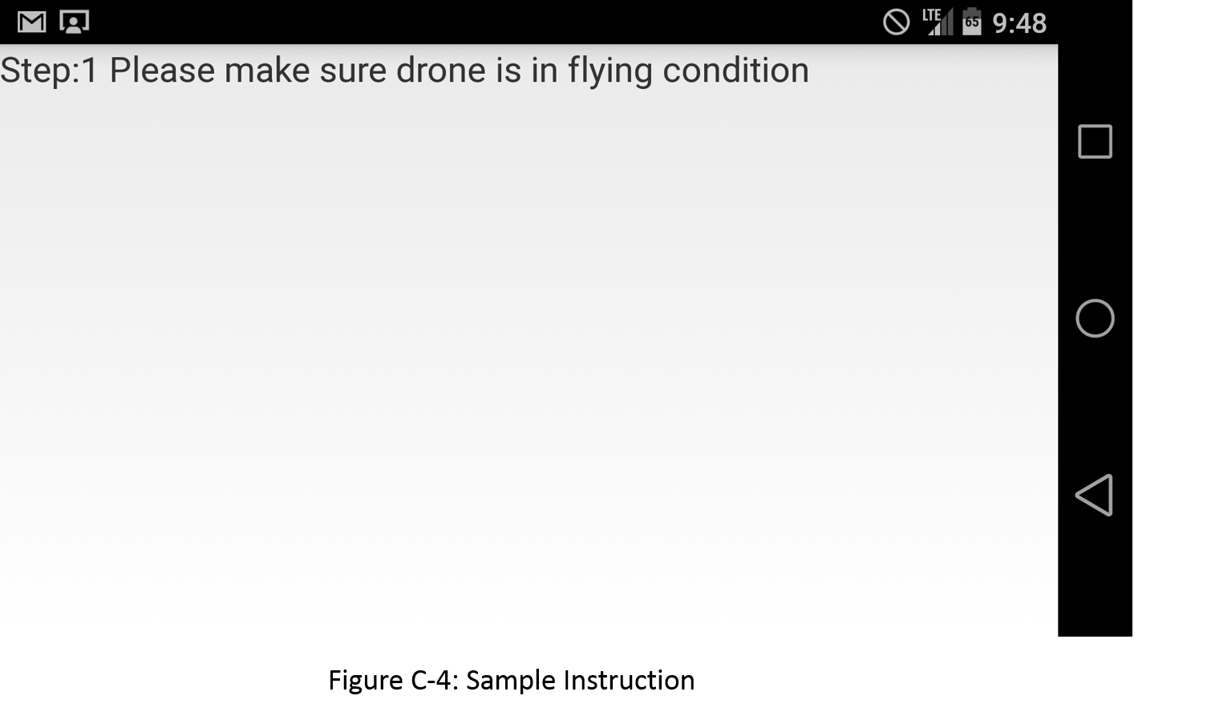

Product Backlog

