Role-Based Security in a Distributed Resource Environment∗

Profs. S. A. Demurjian and T.C. Ting
J. Balthazar, H. Ren, and C. Phillips
Computer Science & Engineering Dept.
The University of Connecticut
Storrs, CT 06269-3155
steve@engr.uconn.edu
Tel: 860.486.4818
Fax: 860.486.4817
Dr. P. Barr
The MITRE Corp
145 Wyckoff Road
Eatontown, New Jersey 07724
poobarr@mitre.org
Tel: 732-935-5584
Fax: 732-544-8317

Abstract
There are many technologies for distributed processing/interoperation, including CORBA, DCE, DCOM, Enterprise Java Beans, Java IDL, JDBC, etc. Most promising, is the emergence of the distributed resource environment, which allows all of the components that comprise a distributed application (i.e., software components like servers, legacy systems, databases, COTs, etc., and hardware components like printers, scanners, etc.) to be treated akin to operating system resources, where each component (resource) can publish services (an API). Once published, these services are available for use by clients and resources alike. However, distributed resource environments have lagged in support of security, providing minimal functionality to control the availability of a resource’s services to clients. To address this deficiency, this paper concentrates on proposing a technique for seamlessly integrating a role-based security model, authorization, authentication, and enforcement into a distributed resource environment. In addition, we consider the specific challenges and problems in supporting role-based security and authorization in an actual distributed resource environment, namely Sun’s Java-based JINI. JINI promotes the construction and deployment of robust and scalable distributed applications via leasing of services by resources and two-phase commit transactions.

Introduction and Motivation
Distributed computing applications for the 21st century, constructed from legacy, commercial-off-the-shelf (COTS), database, and new client/server applications, will require stakeholders (i.e., software architects, system designers, security officers, etc.) to architect and prototype solutions that facilitate the interoperation of new and existing applications in innovative ways. To adequately support this, the network and its software infrastructure must be an active participant in the functional processing of distributed applications, and security must play a fundamental role. The emergence of distributed computing technology such as DCE [OSF94, Rose92], CORBA [OMG95, Vino97, Yang96], and DCOM [Micr95], has enabled the parallel and distributed processing of large, computation-intensive applications. The incorporation of security has often been dependent on programmatic effort rather than a cohesive mechanism seamlessly incorporated into the underlying technology. For example, even though CORBA contains individual security services for confidentiality, integrity, accountability, and availability, there is no cohesive CORBA service that ties these and other concepts (authorization, authentication, and privacy) together into a cohesive security solution. However, there has been significant progress in distributed authentication in Kerberos [Neum94] and Cheron [Fox96], security metric analysis and design [Reit99], Internet security via firewalls [Oppl97], role-based access control on Web-based intranets [Sand98], and security for mobile agents [Swar97, Wall98].
Our specific interest is in distributed applications that plug-and-play, allowing us to plug in (and subtract) new “components” as needs, requirements, and even network topologies change over time. Historically, the plug-and-play of components on a network has concentrated on hardware resources (e.g., printers, RAID arrays, scanners, etc.) that have defined operating system services, published via an application programmers interface (API). We extend the concept of plug-and-play resources to include software in addition to hardware, where all of the resources (e.g., legacy, COTS, databases, servers, etc.) have services that are published (via APIs) for use by distributed application components. The resources, their services, and the clients, interacting across the network, comprise the distributed resource environment for the distributed application. Our goal in this paper is to leverage the infrastructure of a distributed resource environment, to support and realize role-based security. In such a setting, we propose a software architecture with specialized security resources that interact with non-security resources and clients, to authorize, authenticate, and enforce security for a distributed application in a dynamic fashion. To demonstrate the feasibility of our approach, we exploit Sun’s distributed resource environment JINI [Arno99, JINI, JINIARCH].
JINI promotes the construction and deployment of robust and scalable distributed applications, providing the infrastructure for a distributed resource environment. In JINI, a distributed application is conceptualized as a set of services (of all resources) being made available for discovery and use by clients, which forces software engineers to adopt a client/services view. To accomplish this, JINI makes use of one or more Lookup Services. Resources in JINI discover and then join the Lookup Service, registering their services for network availability. A distributed resource environment, in general, and JINI, in particular, has goals that include: network plug-and-play of clients and services; enabling spontaneous network centric applications; and promoting an architecture where the services define the functionality. However, despite these goals, the technology lacks the ability to restrict what a client can and cannot do, i.e., the services of a resource are available to any and all clients without restriction.
Our main purpose of this paper is to examine the incorporation of a role-based approach to security within a distributed resource environment, in general, and JINI, in particular, which supports the selective access of clients to resources. We propose a software architecture and security specific resources to support authorization (grant and revoke privileges to clients based on role), authentication (verify the identity of clients), and enforcement (insure that a client only uses those services of a resource to which it has been authorized). Our fundamental objective is to propose a security solution for distributed applications built around the concepts of clients and resources, operating within a distributed resource environment. Within this context we provide role-based access to services based on our previous object-oriented efforts [Demu97], without programmatic changes to a resource, allowing the resource to dynamically discover security privileges from security resources. To illustrate the feasibility of our approach, we have implemented a prototype using JINI that supports multiple clients with authorization, authentication, and database resources, with the enforcement achieved through a combination of the interactions of resources and a client. This work augments our prior efforts on software architectures [Demu98] and software agents [Demu99] for our role-based security [Demu97].
The remainder of this paper is organized as follows. Section 2 provides background material on JINI. Section 3 proposes a software architecture for role-based security for a distributed resource environment. Section 4 reviews our prototyping efforts with JINI. Section 5 compares our work to other relevant efforts. Finally, Section 6 presents concluding remarks and future research.

JINI
JINI allows stakeholders to construct a distributed application by federating groups of users (clients) and the resources that they require [Arno99, Edwa99, JINI, JINIARCH, Wald99]. In JINI, the resources register services which represent the methods (similar to an API) that are provided for use by clients (and other resources). In JINI, a resource can represent any entity that can be used by a person, program (client), or another resource, including: a computation, a persistent store, a communication channel, a software filter, a real-time data source (e.g., sensor or probe), a printer, and so on. A Lookup Service is provided by JINI, and operates as a clearinghouse for resources to register services and clients to find services. The registration of services occurs via a leasing mechanism. With leasing, the services of a resource can be registered with the Lookup Service for a fixed time period or forever (no expiration). The lease must be renewed by the resource prior to its expiration, or the service will become unavailable. From a security perspective, the lease that is given by a resource to its services is not client specific. Once leased, a service is available to all, even if the service was intended for a targeted client or group of clients. Our work in this paper seeks to address and overcome this limitation.
A distributed application constructed under the JINI framework is designed around the utilization of one or more Lookup Services, as shown in Figure 2.1. The Lookup Service is key, through which all interactions by resources (e.g., discovering Lookup Services, registering services, renewing leases, etc.) and by clients (e.g., discovering Lookup Services, searching for services, service invocation, etc.) must occur. When there are multiple Lookup Services running on a network, it is the responsibility of the resources to register with them (if relevant). Clients can interact with multiple Lookup Services, and groups of clients can be established that will always consult a particular “close” Lookup Service based on network topology or traffic. Whenever resources leave the environment (either gracefully or due to failure), the Lookup Service must adjust its registry. There is a time lag between the resource leaving and the removal of services from the registry. Clients must be sophisticated enough to be able to adjust to this situation.
After discovery has occurred, the resources must register their services on a class-by-class basis with the Lookup Service. The class is registered as a service object which contains a Java programming interface to the service, namely, the public methods available to clients coupled with a set of optional descriptive service attributes. The service object is registered as a proxy, which contains all of the information that is needed to invoke the service. One limitation of this process is that once registered, a resource’s services are available to all clients; JINI does not provide the ability to have services registered that are only available to certain clients. Once the resources have registered their services, clients can discover and request services. In the request for service, shown in Figure 2.1, a client will ask for a CourseDB service to register for a class based on the signature of the method: status register_for_course(int). The Lookup Service will return a service proxy to the client. This proxy allows the client to invoke any or all of the methods defined within the service. Using the proxy, the client invokes the needed method(s) as it would any other Java method; the proxy allows the invocation to occur remotely at the resource with the result of the call returned to the client.
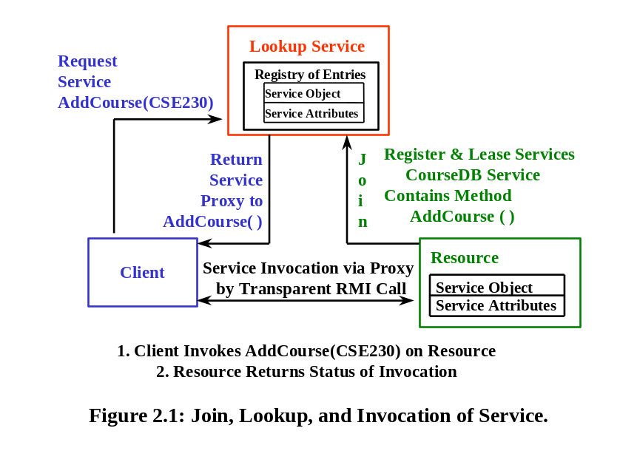

A Software Architecture for Role-Base Security
In a distributed resource environment, all of the different resources (hardware or software) are treated in a consistent fashion, allowing all of the clients and resources to be seamlessly integrated. Clients consult the Lookup Service to locate and subsequently execute the “services” of the “found” resource that are necessary to carry out their respective tasks. If one of the resources fails, making its services unavailable, the Lookup Service can be asked to locate another resource that provides the desired service. However, distributed resource environments are lacking in their support of security. When a resource registers its services with the Lookup Service, there is no way for the resource to dictate which service can be utilized by which client. If the resource wants to control access to its services, it must do so programmatically, putting in clients-specific code within the implementation of the service. When changes need to be made, they must occur at the code-level, and will typically require recompilation, which is not an attractive option. We are interested in extending the security capabilities of a distributed resource environment to allow resources to selectively and dynamically control who can access its services (and invoke their methods), based on the role of the client. Our solution exploits the distributed resource environment, by defining dedicated resources to authorize, authenticate, and enforce role-based security for the distributed application. The remainder of this section is organized to propose and discuss: a software architecture for role-based security in a distributed resource environment (Section 3.1), the security resources and services for such an architecture (Section 3.2), and the usage of the solution by clients and resources (Sections 3.3 and 3.4).

A Proposed Software Architecture
A software architecture for supporting role-based security in a distributed resource environment is presented in Figure 3.1, and contains a set of clients that seek to utilize a set of resources, one or more Lookup Services that allow clients to find resources (and their services), and three security-specific resources: Role-Based Privileges, Authorization List, and Security Registration. The Role-Based Privileges resource tracks the services of each resource, and for every service, the methods that are defined. Each user role may be granted access at varying levels of granularity, allowing a role to be assigned to a resource (i.e., able to use all of its services and all of their methods), to a service (i.e., able to use all of its methods), or to individual methods (i.e., restricted to specific methods of a service). The Authorization-List resource maintains a list of all users (e.g., clients, individuals, tools, etc.), and for each user, tracks the roles that they have been authorized to play. Finally, the Security Registration resource tracks the current active users uniquely identified by a triad of <name, IP address, user role>. The architecture supports the following capabilities:
- Role-based authorization to grant and revoke resources, their services, and their methods on a role-by-role basis for use by clients. This is accomplished using the Role-Based Privileges and Authorization-List resources. A special security client (see Section 3.3) can be utilized by the security officer to maintain and modify this security data.
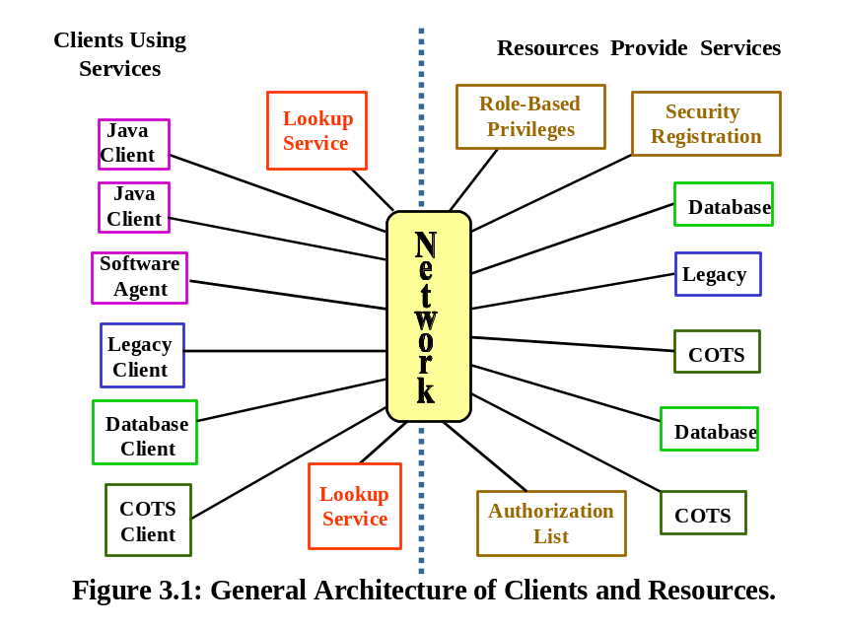
- Client authentication for the verification of the identity and role of client. This is supported by the Security Registration resource, which tracks all active clients (name, IP address, role), and is used by resources whenever a client attempts to access a service.
- Customized resource behavior so that the client and its role dynamically determines if a particular service of a resource can be used. A resource utilizes all three security specific resources to control access to its services by clients.
The term “client” is used in a general sense; resources can function as “clients” to access other resources as needed to carry out their functions. This is true in the third capability above, where each resource can act as a client when it needs to access the security specific resources.

Security Resources and Services
This section examines the Role-Based Privileges, Authorization List, and Security Registration resources (see Figure 3.1). All of the security information, modeling, and behavior employ a role-based approach to discretionary access control [Demu97, Loch88, Sand96, Spoo89]. In a distributed resource environment, the computational and abstraction model is to define, for each resource, a set of one or more services, and for each of the services, to define a set of one or more methods. Under this model, clients are usually given the ability to discover the resource (see Section 2 again), discover its services, and invoke their methods. There is no a priori way to selectively control which client can utilize which resources (and its services and their methods). We leverage our past work [Demur97] on selectively allowing the methods defined on object-oriented classes to be assigned on a role-by-role basis as a basis to selectively control which clients can access which resources. The role-based security model presented herein, as realized with the three security specific resources, will focus on the ability to grant and revoke privileges on a resource basis (all services and their methods), on a service basis (all methods of a service), and on a method basis (individual methods of a service) to clients playing roles.

Role-Based Privileges Resource
The Role-Based Privileges resource is utilized by the security officer to realize the defined security policy for a distributed application to: define user roles; grant access of user roles to resources, services, and/or methods; and, when appropriate, revoke access. The Role-Based Privileges resource is utilized by the resources (e.g., legacy, COTS, database, Java server, etc.) that comprise the distributed application to dynamically determine if a client has the required permission to execute a particular service. To facilitate the discussion, consider the definitions:
Definition 1: A Resource is a system (e.g., a legacy, COTS, database, Web server, etc.) that provides functions for the distributed application via a collection of services, 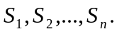
Definition 2: A Service, 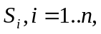is composed of 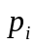 methods 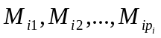where each method 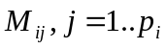 is similar to an object-oriented method, and each method represents a subset of the functionality provided by the service.
Definition 3: A Method of a service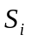 is characterized by a signature (i.e., method name, list of parameter names and types, and return type).
Definitions 4, 5, and 6: Each resource has a unique resource identifier that allows the distributed resource environment (e.g., JINI) to differentiate between replicated resources. Each service has a unique service identifier to distinguish the different services within a particular resource. Each method has a unique method signature that permits overloading of method names while allowing the methods of the same service to be distinguished.
Each triple of <resource identifier, service identifier, method signature> is a unique identifier for the method across the entire distributed application.
Given these definitions, we can now define the concept of user role, which leads to the granularity level of assigning and revoking privileges. In our past work [Demu97], we proposed a user-role definition hierarchy to characterize the different kinds of individuals (and groups) who all require different levels of access to an application. For the purposes of this discussion, we focus on the leaf nodes of the hierarchy, were user roles are defined.
Definition 7: A user role, UR, is a uniquely named entity that represents a specific set of responsibilities against an application. Privileges are granted and revoked as follows:
- UR can be granted access to resource R, denoting that UR can utilize all of R's services, 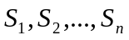, and, for all all of the methods .
- UR can be granted access to a subset of the services of resource R, denoting that UR can utilize all of the methods defined by that subset.
- UR can be granted specific access to individual methods via the triple of <resource identifier, service identifier, method signature>.
Once granted, access to resources, services, and/or methods can be selectively or entirely revoked by a security officer. The granularity of user roles may be fine or coarse at the discretion of a security officer. For example, user roles in a university application may include faculty, student, transcript-issuer, or be task oriented, such as advise-student, record-grades, etc.
Given these definitions, the Role-Based Privileges resource maintains the following information:
- A resource list, indexed by <resource identifier> and for each resource, a list of all of the user roles that have been granted access.
- A service list, indexed by <resource identifier, service identifier>, and for each service, a list of all of the user roles that have been granted access.
- A method list, indexed by <resource identifier, service identifier, method signature>, and for each method, a list of all of the user roles that have been granted access.
- A user-role list, indexed by <role name, role identifier>, and for each user role, a list of all resources, services, and/or methods, to which that user roles has been granted access.
The information of the Role-Based Privileges resource can be manipulated by the different clients that are part of the distributed application, as follows:
- Each resource must register with the Role-Based Privileges resource, so that the master resource list, service list, and method list, can be modified to include resources as they dynamically enter the environment. Resources must be allowed to both register and un-register services/methods. The Register service in Figure 3.2 supports these actions.
- Each resource, when consulted by a client (e.g., GUI, software agent, another resource, etc.), asks the Security Registration resource if the client has registered, (see Section 3.2.3) and if so, asks the Role-Based Privileges resource if the client has been granted access to a service/method pair based on the client’s role. The Query Privileges service in Figure 3.2 supports this action.
- There is a Security Client (see Section 3.3), utilized by the security officer to define and remove user roles and to grant and revoke privileges (resources, services, and/or methods) to the user roles of the distributed application. The Grant-Revoke-Find service in Figure 3.2 is for the maintenance of the privileges that define the security policy of the distributed application.
To simplify the presentation, in Figure 3.2 we have omitted return types. For example, the majority of the methods will return a success/failure flag, the Check_Privileges will return a yes/no, and the Finds will return result sets. Note that the services in Figure 3.2 represents a general characterization of the services (and their methods) for all three security specific resources. However, we make no claims of completeness. In fact, since the prototyping is ongoing (see Section 4) and our future work is extensive (Section 6), these services may change and others may be required. Over the past six months, three graduate students have actively worked on this project, and we report on our initial prototyping of the security client and the services from Figure 3.2 in Section 4.2.
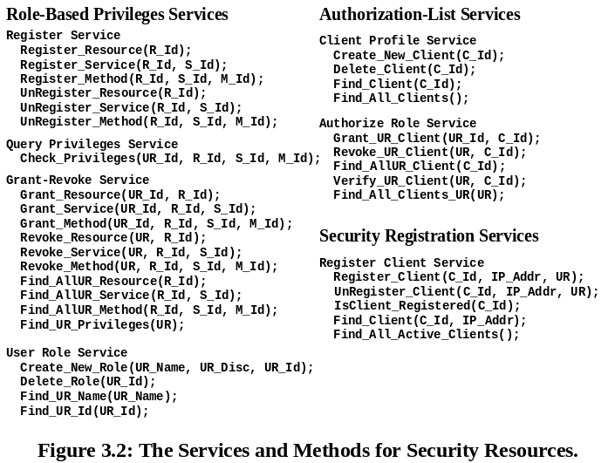

Authorization-List Resource
The Authorization-List resource maintains profiles on the clients (e.g., users, tools, software agents, etc.) that are actively utilizing services within the distributed application. The identification of users is more problematic in a distributed setting, since a user may not be an actual person, but may be a legacy, COTS, database, agent, etc. This leads to the definition:
Definition 8: A client profile, CP, characterizes all of the pertinent information needed by a resource to dynamically verify whether a client can access the desired triple of <resource identifier, service identifier, method signature>.
The Authorization-List resource maintains the client profiles via the two services shown in Figure 3.2. The Client Profile service is utilized by the security officer, via a Security Client (see Section 3.3), to create and manage the profiles for clients. The Authorize Role service is also utilized to verify whether a client has registered with a particular role (see Section 3.4 ). We are purposely being vague about what constitutes client identification (C_Id in Figure 3.2). While it may be as simple as a client name and password, it may need to be more complex (e.g., client name, password, IP address, port number, etc.), to uniquely distinguish clients.

Security Registration Resource
The Security Registration resource is utilized by clients at start-up time for identity registration (client id, IP address, and user role) and by the Security Client (see Section 3.3). The Register Client service, shown in Figure 3.2, allows a client to have access to resources and their services. Every non-security resource utilizes the Security Registration resource to dynamically determine if the client who wants to invoke the service has registered via the IsClient_Registered method. If the client has not registered, the resource will deny service by not invoking the method. Collectively, the Security Registration, Authorization-List and Role-Based Privileges resources, allows the security officer to manage, modify, and monitor the security policy.

Security Client and Resource Interactions
To further explain the security processing in the distributed resource environment, Figure 3.3 contains a depiction of a Security Client and a General Resource (e.g., legacy, COTS, database, etc.). For the Security Client, Figure 3.3 contains the services from the three security resources that can be used to establish the security policy by creating/finding clients, authorizing roles to clients, and granting, revoking, and finding the privileges that a role has against a resource, service, and/or method. For the General Resource, there is the requirement to register itself, its services, and their methods with the Role-Based Privileges resource (see Figure 3.3). Registration allows entries to be created on the resource, service, and method lists that can then be accessed via the Security Client. Note that the Security Client and General Resource must discover the services in Figure 3.3, prior to their invocation, as represented by the dashed arrows.

Client Interactions and Processing
Finally, to fully illustrate the general process for a GUI Client accessing a Database Resource using the Lookup Service, and the Security Registration, Authorization List, and Role-Based Privileges resources, we present an example in Figure 3.4, with flow via the numbered service invocations and returned results. To reduce the confusion in the figure, we have omitted all of the discoveries and proxy returns that would be required for the actions labeled 1, 2, 5, 6, and 8. The actions that occur can be illustrated with the method call represented by the arrow labeled “1. Register_Client.” Prior to this method call, the GUI Client would ask the Lookup Service for a resource that provides the Register Client Service (part of the Security Registration resource as shown in Figure 3.2). The Lookup Service would return a proxy to the Register Client Service, and the GUI would use this proxy to execute the Register_Client method.
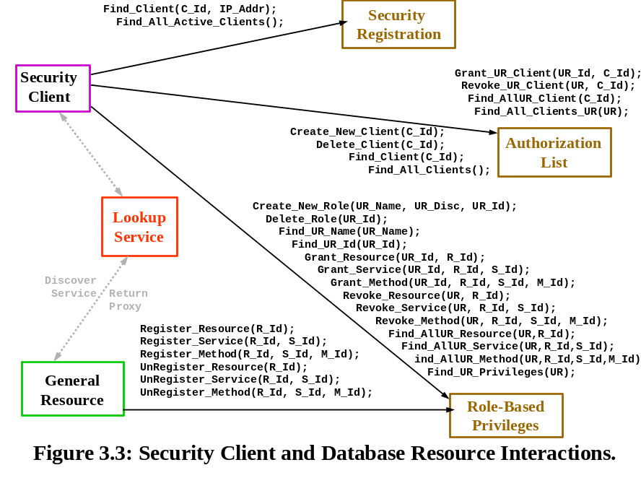
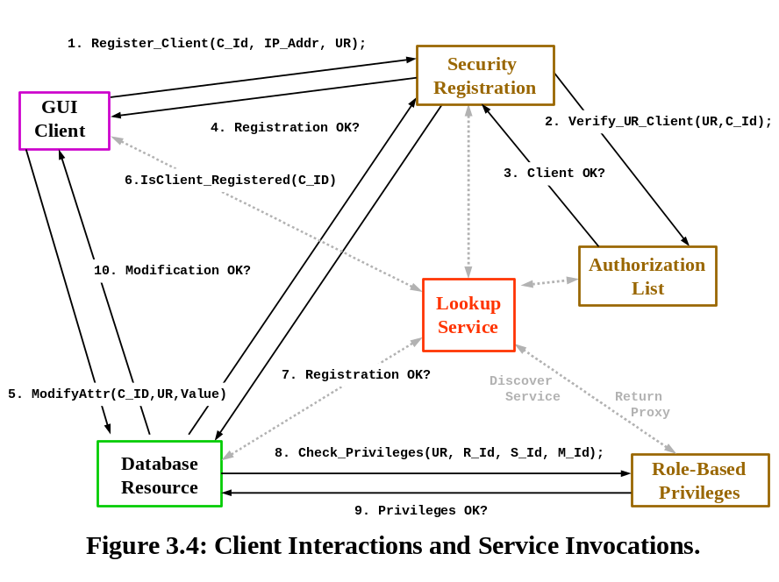
With the discovery/proxy process described, the example can be explained by figure starting when a client enters the distributed resource environment. The client must make itself known by registering with the Security Registration resource. The arrows labeled 1, 2, 3, and 4 facilitate the registration process, by requiring the client to register itself with the Security Registration resource (arrow 1), which in turn interacts with the Authorization-List resource to determine if the client has been authorized to play the desired role (arrow 2). Arrows 3 and 4 complete the process and will return either success or failure. For this discussion, we assume that success is returned. Note that clients that have not registered will still be able to discover resources and services via the Lookup Service. But, they will be prohibited from executing those services if they have not registered. This will become clear as we continue with the example.
After the Client has successfully registered, it can then discover services via the Lookup Service. Suppose that the Client has discovered the ModifyAttr method that is part of the Update Database Service for the Database Resource (arrow 5 in Figure 3.4). When the Database Resource receives the ModifyAttr invocation request, the first step in its processing is to verify if the client has registered by interacting with the Security Registration resource (arrows 6 and 7). If so, then the Database Resource must then check to see if the client playing the particular role has the required privileges to access the ModifyAttr method, which is accomplished via arrows 8 and 9 by consulting the Role-Based Privileges resource. If the Database Resource receives a response to indicate that the GUI Client has the privileges to access the method, it will then execute the ModifyAttr method and return a status to the Client (arrow 10). Successive service discoveries and method invocations by the Client for the Database Resource or any other resource in the distributed application will have similar processing.

Experimental Prototype
This section reviews our prototyping efforts on utilizing JINI to support the software architecture for a distributed resource environment, as presented in Section 3. We have implemented the prototype on Windows NT 4.0, using Java 1.2.2 and JINI 1.0. To support the prototyping effort, we employ a university application where students can query course information and enroll in classes, and faculty can query and modify the class schedule. We have implemented two prototypes to date. In the first prototype, described in Section 4.1, we implemented a subset of our architecture from the client and services perspective, allowing a GUI client to issue requests against a database resource that must satisfy role-based security privileges. To accomplish this, the Authorization-List resource has a subset of the services from Figure 3.2, with the Security Registration and Role-Based Privileges resources combined (also with a subset of services). In the second prototype, presented in Section 4.2, we have designed and implemented the Security Client (see Section 3.3) and all of the security services as shown in Figure 3.2. A number of bitmaps have been included from the tool, and are briefly explained. Our next prototype, currently under development, will seek to integrate the first two prototypes into a more robust baseline system.

Baseline Prototype for GUI Security Interactions
Students and faculty have a GUI (Java client application) through which they must enter their name, password, and role. This information must be checked against the Authorization-List resource, which has been implemented as a Microsoft Access database. The clients can interact with one of the replicated CourseDB resources (also implemented as a Java application using JDBC and Access), to access and/or modify the database based on their role. The resulting CourseDB Resource, as shown in Figure 4.1, contains a single DBServer service (with seven methods) that is registered with JINI for use by clients. The two user roles are Faculty and Student, with Faculty granted access to all methods but EnrollCourse, and with Student granted all but AddCourse, RemoveCourse and UpdateCourse. The prototype had two GUI clients running simultaneously (one with role Faculty and one with role Student), one CourseDB resource, two Authorization-List resources, two Role-Based Privileges/Security Registration resources, and one JINI Lookup Service, all executing on the same NT workstation.
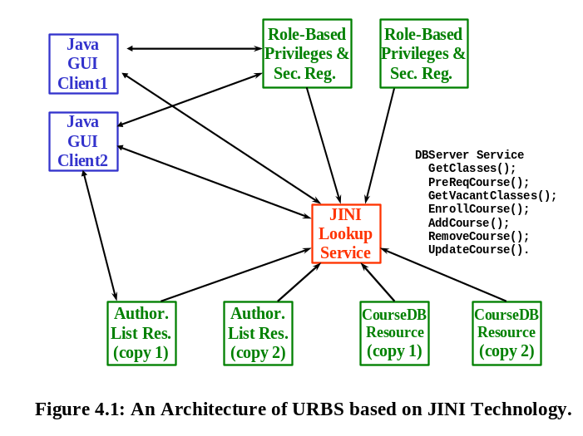
The processing for the prototype mirrors our discussion in Section 3.4, and is shown in Figure 4.2. We have only shown one copy of each security resource, since discovery by the Java GUI Client will always result in the return of the proxy to one of the replicated resources. The processing in steps 1 through 10 represents a successful case (a client does have permission based on role to invoke a method). In the prototyping effort to date, we have also proven the negative case (client attempts to invoke desired method and is denied by the resource).
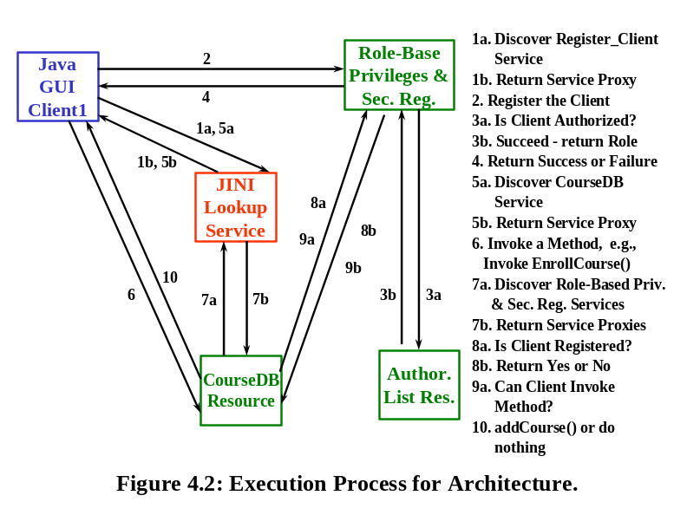

The Security Client Prototype
In this section, we review our initial work on a Security Client (see Section 3.3) that allows a security officer to interact with all of the services defined in Figure 3.2 for creating roles and assigning privileges. This proof of concept prototype is different from our previous work (Section 4.1) in that it is a generic security tool that can be adapted to a number of applications requiring role-based security. This tool eliminates the need for some of the role-based programming completed in the University Database Prototype (see Section 4.1), since the tool can now define the roles. This is a tool that is intended to be utilized by an organization's security officer to design, implement, and maintain the security policy for a given application. As with the prototype in Section 4.1, the Security Client prototype interacts with database resources implemented using JDBC and Access.
The Security Client uses a GUI, the first screen of which is shown in Figure 4.3, and divides security resources into three categories as represented by the indicated buttons. The categories are the same as those given in Figure 3.2: Role-Based Privileges Services, Authorization-List Services, and Security Registration Services. Each of these categories has their own screen to be utilized by a security officer, all of which are reached through this initial Security Client screen.

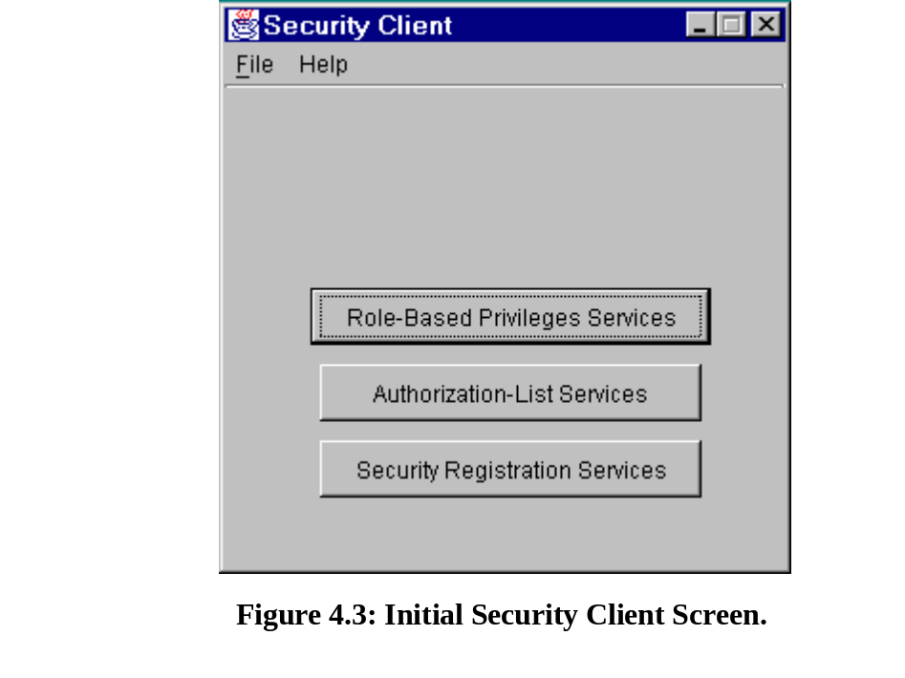

If the security officer selects the first button, the screen for the Role-Based Privileges Services is presented, as shown in Figure 4.4, and is organized according to the services given in Figure 3.2. The services in Figure 4.4 are Register Service, Query Privileges Service, User-Role Service, and Grant-Revoke Service. Each service is further decomposed into their respective function. That is, depending on the option that is selected (create new user role in Figure 4.4), data entry boxes appear at the bottom of the screen to allow for the relevant operation. In the case of Figure 4.4, this allows for a user role name, user role identifier, and user role description to be entered for a new user role. Other selections of the radio buttons will yield different sets of data entry and/or query boxes based on the desired operation. All of the different screens of the Security Client (see Figures 4.4 through 4.6) work in a similar fashion.

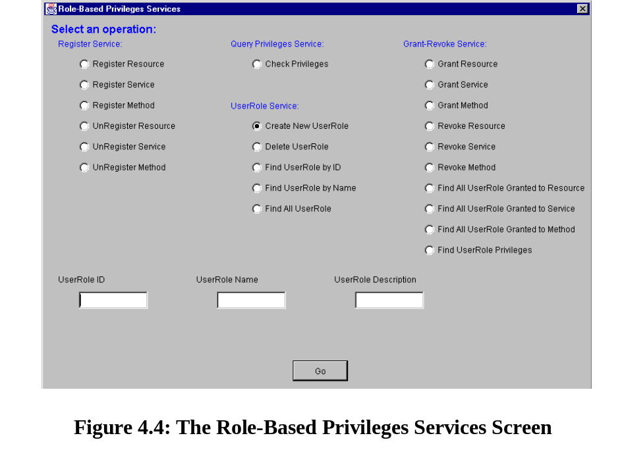

The Authorization-List Services screen, when selected from the initial screen (see Figure 4.3), is shown in Figure 4.5, and is organized to mirror the services in Figure 3.2. These services are classified as either the Client Profile Service or the Authorize Role Service. The service selected in Figure 4.5, revoke client with user role, causes data entry boxes for the client identifier and user role to appear, which the security officer can utilize to accomplish the revocation. Upon selection, the other radio buttons cause appropriate data entry boxes appear.

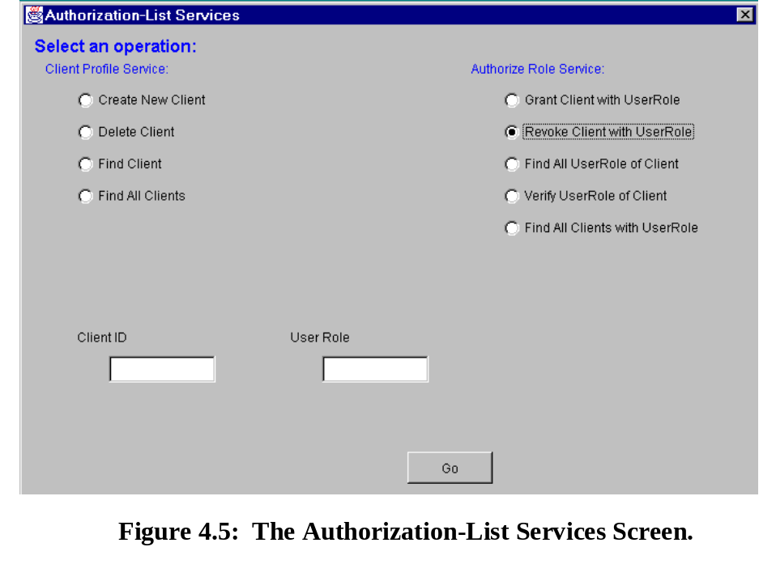

When the Security Registration button is selected from the initial screen (Figure 4.3), the resulting screen as shown in Figure 4.6 is displayed. The Registration Service, as currently conceptualized, has only a single service, the Register Client Service (see Figure 4.6). When the security officer selects one of the radio buttons, the relevant data entry boxes are displayed. In the case of Figure 4.6, the unregister a client button causes data entry boxes for the client identifier, client IP address, and user role to be displayed.

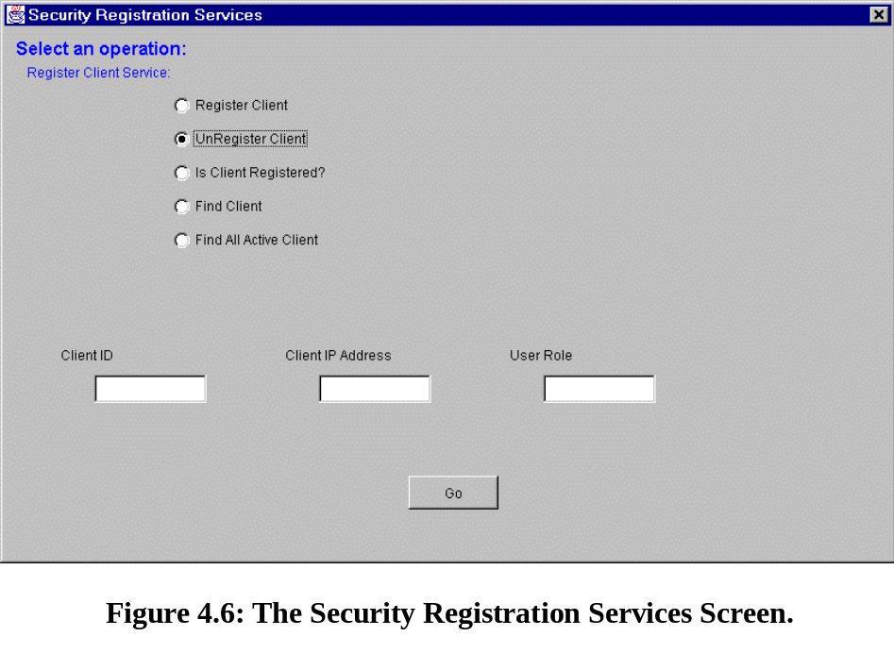

Related Work
In this section, we review related efforts and contrast their work with our effort. In the area of security policy and enforcement, there has been work on security filters and screens, header encryption, user-level authentication, IP encapsulation, key management protocols, secure sockets, and secure shell [Oppl97]. This work is important to our effort, since this technology must underlie a distributed resource environment to provide OS-level security. Likewise, there have been studies showing the vulnerability of browser and network programming software to domain name server, spoofing, and denial of service attacks [Kemm97]. Browsers and network programming software are cornerstones of any distributed application, and their vulnerability will increase the difficulty in attaining security within a distributed resource environment.
Encryption is important to network security, and has been used for role identification, delegation of access control, securing a communication channel, and establishing a trusted computer base [Lamp92]. These problems are directly relevant to our work, since clients use service proxies for remotely located resources, and the clients must employ communications channels and have their request processed by a computer whose trust is unknown. In the authentication area, Kerberos, is an authentication service for computer networks that uses encryption to verify both the user and that the message received is the message sent [Nuem94]. Another network protocol, Charon, which uses Kerberos techniques, provides a secure proxy service between client and server services [Fox96]. Using security capabilities from Charon and Kerberos in conjunction with a JINI Lookup Service, could be a major step in insuring the utilization of registered services and assisting in providing secure transmission paths for those services.
As discussed in Section 3, the clients in our approach can be mobile agents, and it is important that we attempt to leverage work in the security of mobile agents and mobile objects in support of our work. There have been several attempts to authenticate objects as they move through the network, including: Saga, a security architecture that controls access to and monitors the security of mobile agents via access tokens, access control vectors, and a security monitor [Sosh97]; Legion, a scalable security policy based on security related functions, where an object may or may not need security protection based its class [Wulf96]; and, Concordia, a framework for developing and executing mobile agent security that offers agent storage protection, transmission protection, and server resource protection [Wall98]. In addition, there are a growing list of efforts that insure that mobile agents are protected, namely: Trust Appraisal [Swar97], Metric Analysis [Reit99], SDSI (Simple Distributed Security) [Rive96], DCM (Distributed Compartment Model) [Gree96] and Short-lived Certificates [Hsu98]. Finally, there is the Seamless Object Authentication (SOA) approach, developed in CORBA and JAVA, which manages the signature of a CORBA client and ACL with a security server [Tezu00]. This effort mirrors our own by examining the realization of security for a distributed architecture.

Conclusions and Future Work
In this paper, we proposed and explained an approach that can authorize, authenticate, and enforce a role-based security solution that operates within a distributed resource environment. As presented in Section 3, our architecture (see Figure 3.1) defined the basis of a role-based security model for a distributed resource environment, specified Security Registration, Authorization-List, and Role-Based Privileges resources and their services (see Section 3.2), and detailed the processing of both clients and resources (see Sections 3.3 and 3.4). We prototyped a subset of our approach using JINI in Section 4 from both the perspective of a GUI client (see Section 4.1) and for the Security Client (see Section 4.2), and reviewed related work in Section 5.
The work presented herein represents the first step in an ongoing effort with one doctoral and two masters students. There are a number of issues under investigation:
- In Section 3.2, resources, services, and methods are assigned to clients based on role. We need to refine the role-based security model to include negative privileges, to definitely state which resources, services, and/or methods are not available to a specific client based on role. For example, when a client invokes a method on resource X that is legitimate, resource X may in turn invoke method M defined on resource Y that should be denied. However, if resource X has been authorized to invoke M, then the client may indirectly obtain results related to M that should have been prohibited.
- In Section 3.3, an important issue that was not addressed involves the potential inconsistency of the Authorization-List and Role-Based Privileges resources when multiple security clients (only one client was shown in Figure 3.3) attempt to simultaneously access these resources (and their). If these resources are relational database applications, the underlying relational database management system may be leveraged to avoid data inconsistencies when multiple security clients are modifying the same role or the same authorization list entry. If not, then the issue is more problematic, and we must develop an appropriate solution for its resolution.
- The leasing concept in JINI (see Section 2 again) sets an alarm that allows a service to expire if it is not renewed by the resource. This raises an interesting question, namely: “Should the availability of services be time dependent, based on “who” wants the services at what time?” For some clients like software agents, having timed privileges may insure that the client is limited in its ability to cause problems.
- The distributed application has clients and resources executing on different nodes in a potentially complex network. Does the location of a client affect the services that may be invoked? Does the location of a resource determine which services are made available to whom? Perhaps intranet and Internet activity should be viewed differently.
- Resources in JINI are stateless in their ability to track a computation over time. When a client invokes a service and obtains a result, that invocation is independent from one that the client will invoke at a later point in time. Thus, each client invocation of a method must include a client identifier (e.g., name, user role, IP address, port number), without which the resource wouldn’t be able to dynamically determine if the invocation should occur. Passing the client identifier is undesirable from a software engineering perspective, as we have previously argued [Demu97]. We are actively seeking to overcome this limitation in our security architecture/services and the JINI prototype.
- Our prototyping work is ongoing, with our focus on integrating the two prototypes from Sections 4.1 and 4.2 into a more robust, fully functional prototype. We are also working on multi-computer prototypes, and are trying to allow Java agents as clients that can then access our resources in a secure fashion. Finally, we are studying the lost update problem that can occur for a concurrently accessed resource via JINI's transaction processing and two-phase commit capabilities.
Overall, we are strongly concentrating our efforts to understand and define security solutions for distributed applications that operate within a distributed resource environment.

References
[Arno99] K. Arnold, et al., The JINI Specification, Addison-Wesley, 1999.
[Demu97] S. Demurjian and T.C. Ting, "Towards a Definitive Paradigm for Security in Object-Oriented Systems and Applications", Journal of Computer Security, Vol. 5, No. 4, 1997.
[Demu98] S. Demurjian, et al., "Software Architectural Alternatives for User Role-Based Security Policies", in Database Security, XI: Status and Prospects, Lin/Qian (eds.), Chapman Hall, 1998.
[Demu99] S. Demurjian, et al., "Software Agents for Role Based Security", in Database Security, XII: Status and Prospects, S. Jajodia (ed.), Kluwer, 1999.
[Edwa99] K. Edwards, Core JINI, Prentice-Hall, 1999.
[Fox96] A. Fox and S. Gribble, “Security on the Move: Indirect Authentication Using Kerberos”, ACM MOBICON 96, Rye, NY, 1996.
[Free99] E. Freeman, et al., JavaSpaces Principles, Patterns, and Practice, Addison-Wesley, 1999.
[Gree96] S. Greenwald, “A New Security Policy for Distributed Resource Management and Access Control”, 1996 ACM New Security Paradigms Wksp., Lake Arrowhead, CA, Sept. 1996.
[Hsu98] Y.-K. Hsu and S. Seymour, “An Intranet Security Framework Based on Short-Lived Certificates”, IEEE Internet Computing, Vol. 2, No. 2, March-April 1998.
[Kemm97] R. . Kemmerer, “Security Issues in Distributed Software”, Proc. of the 6th European Conf. On Software Engineering, held jointly with the 5th ACM SIGSOFT, 1997.
[Lamp92] B. Lampson, et al., “Authentication in Distributed Systems: Theory and Practice”, ACM Trans. On Computer Systems, Vol. 10, No. 4, November 1992.
[Loch88] F. H. Lochovsky and C. C. Woo, "Role-Based Security in Data Base Management Systems", in Database Security: Status and Prospects, C. Landwehr (ed.), North-Holland, 1988.
[Micr95] Microsoft Corporation, “The Component Object Model (Technical Overview)”, Microsoft Press, Redmond, WA, 1995.
[Mill97] M. Millikin, “Distributed Objects: A New Model for the Enterprise”, Data Communications on the Web, http://www.data.com, Feb. 1997.
[Morr97] M. Morrison, et al., Java Unleashed, second edition, Sams.net Publishing, 1997.
[Neum94] C. Nueman and T. Ts’o, “An Authorization Service for Computer Networks”, Comm. of the ACM, Vol. 32, No. 9, Sept. 94.
[OMG95] Object Management Group, “The Common Object Request Broker: Architecture and Specification - Revision 2.0”, Framingham, MA, July 1995.
[Oppl97] Oppliger, R. “Internet Security: Firewalls and Beyond”, Comm. of the ACM, Vol. 40, No. 5, May 1997.
[OSF94] Open Software Foundation, “OSF DCE Application Development Guide - revision 1.0”, OSF, Cambridge, MA, 1994.
[Reit99] M. Reiter and S. Stubblebine, “Authentication Metric Analysis and Design”, ACM Trans. On Information and System Security, Vol. 2, No. 2, May 1999.
[Rive96] R. Rivest and B. Lampson, “SDSI - A Simple Distributed Security Infrastructure”, MIT and Microsoft Co., http://theory.lcs.mit.edu/~rivest/sdsi10.ps
[Rose92] W. Rosenberry, D. Kenney, and G. Fischer, Understanding DCE, O'Reilly & Associates, 1992.
[Sand96] R. Sandhu, et al., "Role-Based Access Control Models", IEEE Computer, Vol. 29, No. 2, Feb. 1996.
[Sand98] R. Sandhu and J. Park, “Decentralized User-Role Assignment for Web-based Intranets”, Proc. of the 3rd ACM Wksp. on Role-Based Access Control, Fairfax, VA, Oct, 1998.
[Sosh97] M. Soshi and M. Maekawa, “The Saga Security System: A Security Architecture for Open Distributed Systems”, Proc. of 6th IEEE Workshop on Future Trends of Distributed Computing Systems (FTDCS '97), Tunis, Tunisia, 1997.
[Spoo89] D. Spooner, "The Impact of Inheritance on Security in Object-Oriented Database Systems", in Database Security, II: Status and Prospects, C. Landwehr (ed.), North-Holland, 1989.
[Swar97] V. Swarup, “Trust Appraisal and Secure Routing of Mobile Agents”, Proc. of 1997 Workshop on Foundations for Secure Mobile Code (DARPA), March 1997.
[Tezu00] S. Tezuka, et al., “Seamless Object Authentication in Different Security Policy Domains”, Proc. of 33rd Hawaii Intl. Conf. on System Sciences, January 2000.
[Vino97] S. Vinoski, “CORBA: Integrating Diverse Applications Within Distributed Heterogeneous Environments”, IEEE Communications Magazine, Vol. 14, No. 2, Feb. 1997.
[Wald99] J. Waldo, “The JINI Architecture for Network-Centric Computing”, Communications of the ACM, Vol. 42, No. 7, July 1999.
[Wall98] Walsh, T., Paciorek, N., and Wong, D. “Security and Reliability in Concordia”, Proc. of the 31st Hawaii Intl. Conf. on System Sciences (HICSS'98), 1998.
[Wulf96], W. Wulf, et al., “A New Model of Security for Distributed Systems”, 1996 ACM New Security Paradigms Workshop, Lake Arrowhead, California, Sept. 1996.
[Yang96] Z. Yang and K. Duddy, “CORBA: A Platform for Distributed Object Computing”, ACM Operating Systems Review, Vol. 30, No. 2, April 1996.
[JINI] http://www.sun.com/jini/
[JINIARCH] http://www.sun.com/jini/whitepapers/architecture.html

This work supported in part by the Mitre Corporation (Eatontown, NJ) and a research grant from AFOSR and presented at IFIP WG 11.3 14th Working Conference on Database Security.

